SENIOR FIVE TERM 3 GEOGRAPHY LESSON NOTES 2026
TOPIC 1/3: Population and Development
Competency: The learner proposes strategies for managing population as a key resource in development through analysing its dynamics and their implications for development at different scales.

Population refers to the number of people l i v i n g in a certain are a (region) a t a given time. The total number of people is established by carrying out population census.
Population census refers to the physical c o u n t i n g o f people in the country after a given period of time. In Uganda, population census is ca rr ie d out after every 10 years.

The importance of population census in the economy

- It helps to determine the total population size and its distribution i n the c o u n t r y . This is important f o r national planning purposes.
- It helps to determine the population growth rate of the country over time. This helps to put in place control measures to regulate the rate of population growth.
- Population figures are used in the calculation per capita income of the country. This gives an indication of standards of living in the country.
- It helps to determine the sex composition of the population that is, the ratio of men to women.
- It helps to show the geographical distribution of the population. This is important for regional resource allocation.
- It helps to determine the rate of internal and external migration. This enables the government to come up with measures to control migration of people.
- It helps to determine the ethnic and religious composition of the population that is, the ratio of the population which belongs to different tribes and religions.
- It is used to determine the population density (number of people per unit area of land). This is used as a basis for demarcating districts for effective service delivery and constituencies for political purposes.
- It helps to determine the population structure and composition in terms of age and level of education of the people. The age structure indicates the number of defendants in the country.
- It is used to determine the occupation composition of the population. This is important for proper manpower planning.

Terminologies used in population.
- Demography. This is the study of the population structure and its composition in terms of age, sex, education levels etc.
- Population explosion. This refers to the rapid increase in the population of a given area relative to the available resources. Population explosion leads to over population in the long run.
- Migration. This refers to the movement of people from one area (region) to another in a given time.
- Immigration. This refers to the movement of people which involves entering and settling into the country from another country.
- Emigration. This refers to the movement of people which involves moving out of the country to settle in other countries.

Factors which influence migration of people
- 1. Imbalances in resource distribution among regions and countries.
- 2. Differences in levels of development between regions and countries.
- 3. Differences in incomes and wages between regions.
- 4. Political instabilities like wars and change of regimes.
- 5. Educational requirements where people are forced to go to other countries (regions) to acquire education.
- 6. Differences in climatic conditions which may be favorable or unfavorable.
- 7. Diseases which may affect certain regions there by pushing people to other regions

- Birth rate (Crude birth rate). This refers to the number of children born alive in a year per thousand of the population. It is expressed as a percentage.

Crude birth rate (CBR) = 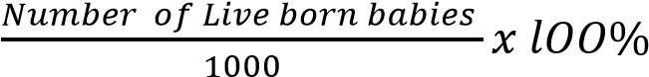

- Death rate (crude death rate]. This refers to the number of deaths in a year per thousand of the population. It is expressed as a percentage.

Crude death rate (CDR) = 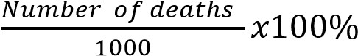

- Natural population growth rate (NPGR). This is the difference between the number of live births per thousand of the population and the number of deaths per thousand of the population in a year.
OR. It is the difference between the crude birth rate and the crude death rate. N.P.G.R = Crude birth rate (CBR) - Crude death rate (C.D.R)
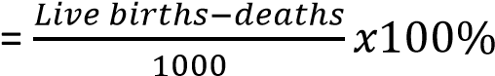

Example 1

In a certain country, the birth rate is 35 per thousand and the death rate is 15 per thousand of the population. Calculate the natural population growth rate.
Solution
N.P.G.R =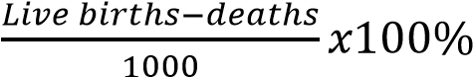
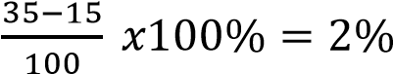
(i) Artificial population growth rate. This is population growth rate resulting from net international migration that is the difference between immigration and emigration.
Actual population growth rate = C.B.R - C.D.R + net international migration

Determinants of population growth rate
- Birth rates
- Death rates
- Immigration
- Emigration

- Dependence burden. This is a situation where there is a big proportion of the nonworking population depending on a smaller proportion of working population
- Dependence ratio. This refers to the ratio of the non-working population to the working population.
Dependence ratio =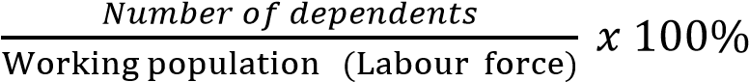

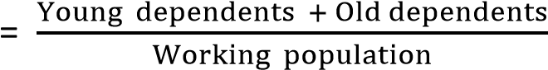 x 100%

Young dependents = people below 18 years; Old dependents = people above 65 years
Active group (working g r o u p ) = 18- 65 years

(m) Fertility rate. This is the average number of live children born per a fertile woman. (For Uganda's case it is six children per woman)

Population distribution
Population distribution refers to the pattern of where people live across the Earth’s surface. It is highly uneven, with some regions densely populated and others sparsely inhabited.

Nature of Population Distribution
- Uneven spread: People cluster in favorable areas (fertile valleys, coasts, cities) and avoid harsh environments (deserts, mountains, polar regions).
- Urban vs. rural: Urban centers attract dense populations due to jobs and services, while rural areas often remain less populated.

• Global examples:
- Dense regions: South Asia (India, Bangladesh), East Asia (China, Japan), Europe.
- Sparse regions: Sahara Desert, Arctic, Amazon rainforest, Australian interior.
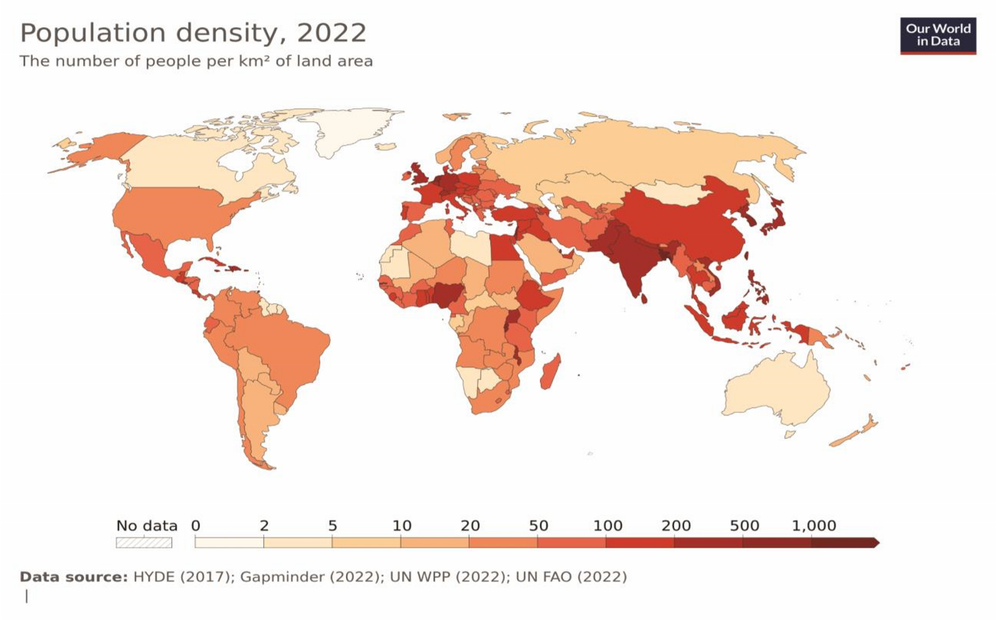

Factors Influencing Population Distribution
- Physical factors: Climate, relief, soil fertility, water availability.
- Economic factors: Employment opportunities, trade, industrialization.
- Social factors: Cultural traditions, education, healthcare.
- Political factors: Stability, government policies, infrastructure.
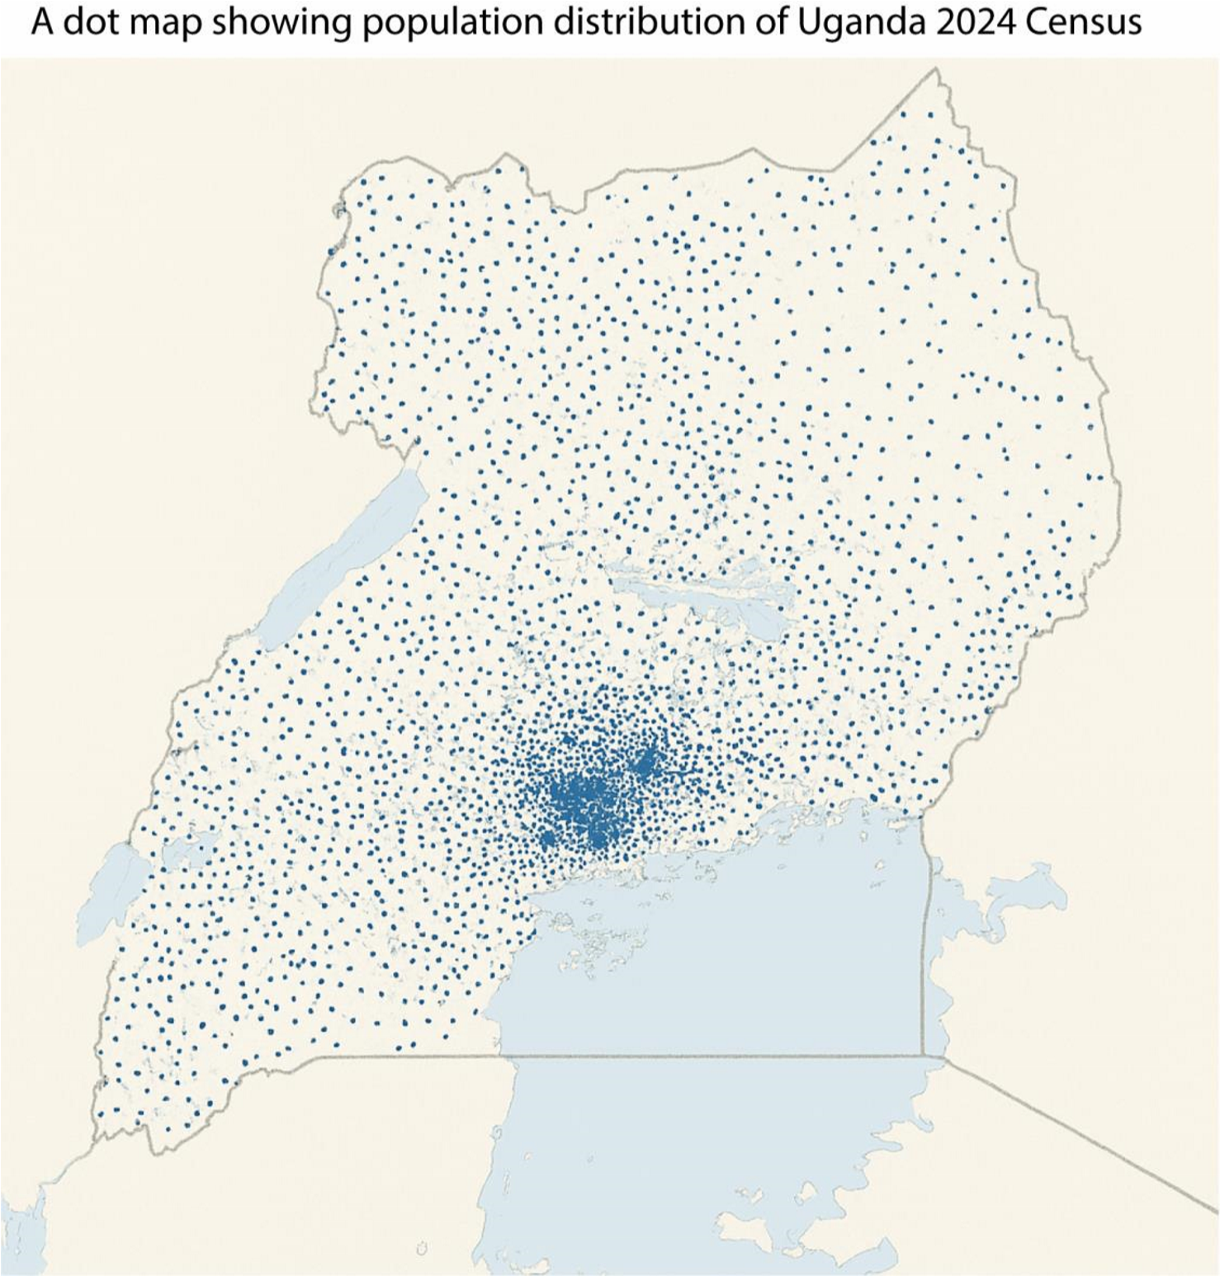
A dot distribution map (or a dot density map or simply a dot map) is a type of thematic map that uses a point symbol to visualize the geographic distribution of a large number of related phenomena.
- Dense clusters around Kampala and Wakiso, reflecting high urban population.
- Moderate density in districts like Mbale, Jinja, and Mbarara, due to fertile land and trade.
- Sparse dots in Karamoja and northern Uganda, indicating low population density due to arid climate and pastoralist lifestyles
Advantages of Dot Maps
- Easy visualization: They clearly show how phenomena (like population) are spread across a region.
- Density differences: Effective in highlighting areas of high vs. low concentration.
- Flexibility: Can represent many types of data (population, resources, events).
- Simple interpretation: Easy for non-specialists to understand patterns at a glance.
- Avoids distortion: Unlike choropleth maps, dot maps don’t exaggerate large areas with small populations.
Disadvantages of Dot Maps
- Time-consuming: Plotting dots accurately requires effort, especially for large datasets.
- Overcrowding: At small scales, too many dots can clutter the map and reduce readability.
- Imprecise values: Hard to retrieve exact numbers—dots show distribution, not precise counts.
- Symbol choice issues: Selecting dot size and value can distort perception if not carefully chosen.
- Generalization: Dots may be placed randomly within areas, which can mislead about exact locations.
Population density
Population density is a measure of how many people live in a given area, usually expressed as persons per square kilometer (km²). It helps us understand how crowded or spacious a region is and is a key concept in human geography.
Choropleth map
A choropleth map is a type of thematic map where areas (such as countries, states, or districts) are shaded or colored in proportion to a statistical variable. It visually represents how a measurement varies across a geographic region, making it easy to spot patterns and differences.
Key Features of Choropleth Maps
- Color-coded regions: Each area is filled with a color or shade based on data values.
- Data-driven visualization: Commonly used for population, income, literacy, rainfall, or disease rates.
- Geographic boundaries: Uses political or administrative borders (e.g., districts, provinces).
- Legend included: Explains what each color or shade represents.
Example Applications of Choropleth Maps
- Population density: Darker shades for more densely populated areas.
- COVID-19 cases: Color intensity shows infection rates by region.
- Election results: Different colors for political party dominance.
- Rainfall distribution: Shades represent precipitation levels across regions.

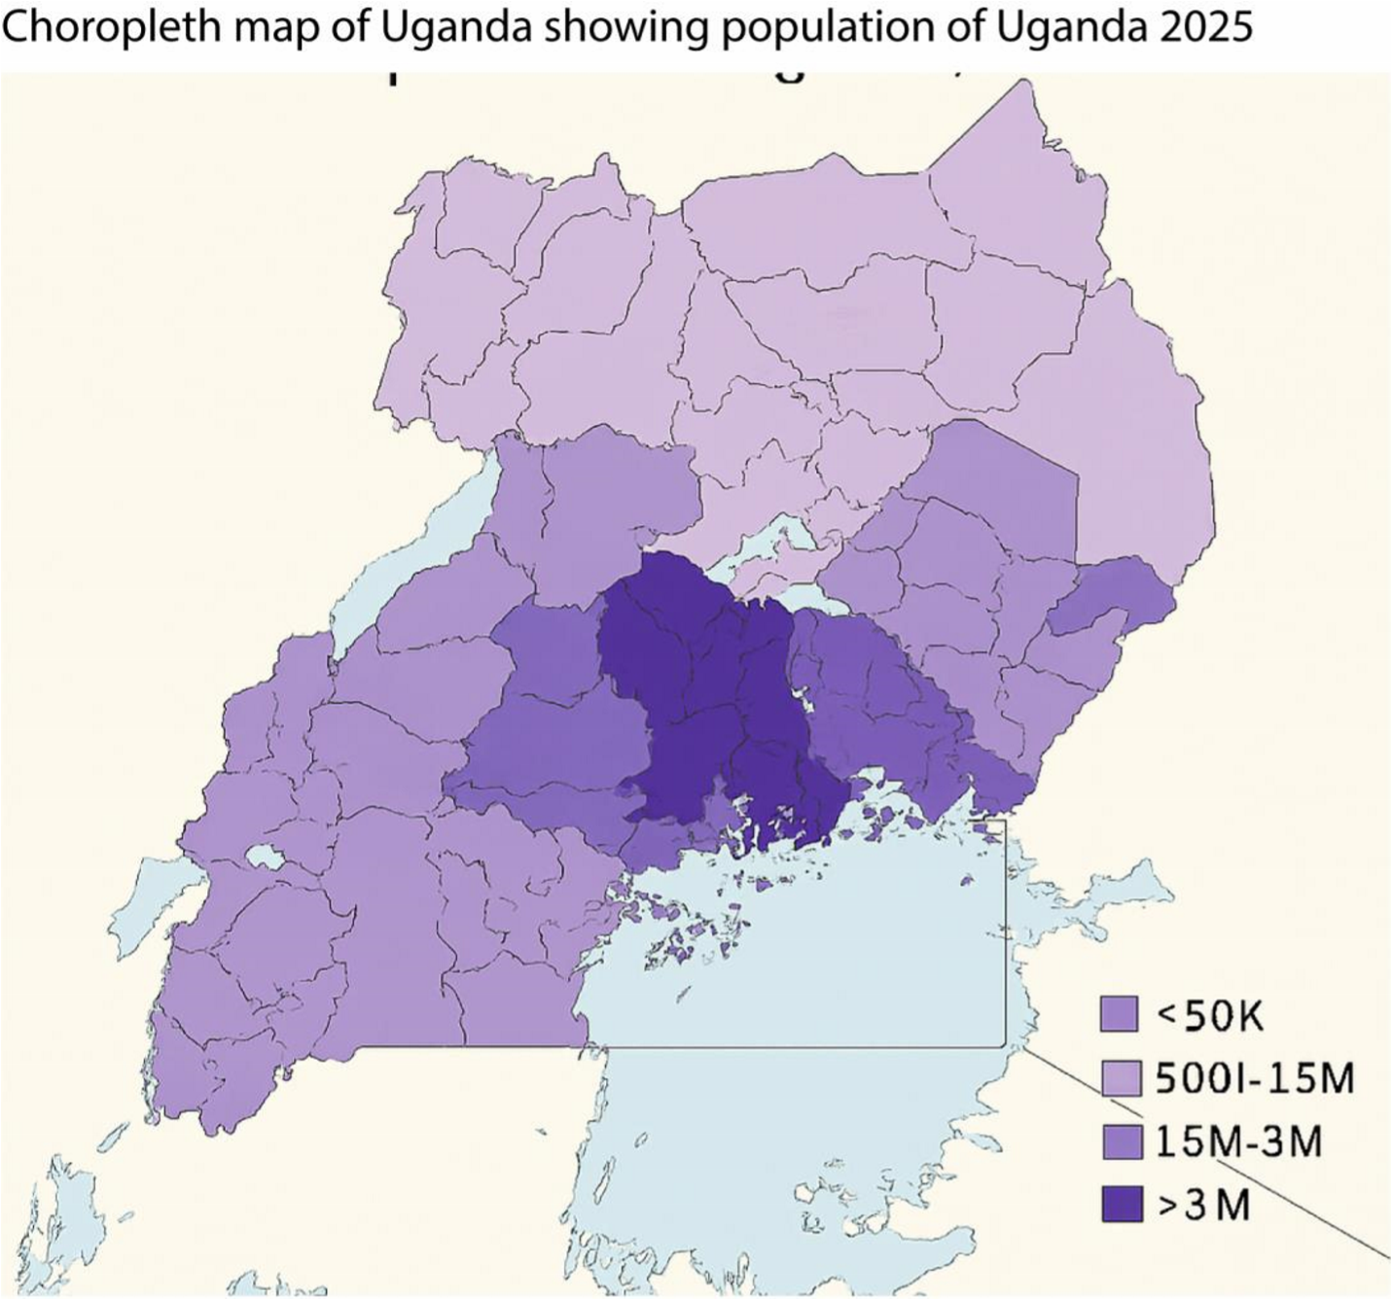

Advantages of Choropleth Maps
- Easy to interpret large datasets spatially.
- Highlights regional disparities and trends.
- Useful for policy-making, planning, and education.
Limitations of Choropleth Maps
- Can be misleading if regions vary greatly in size.
- Doesn’t show intra-region variation.
- Requires careful choice of color scale and classification.
The implications of population distribution and density for resource utilisation and development in Uganda
Uganda’s population distribution and density patterns have direct consequences for how resources are used and how development unfolds. The 2024 census shows Uganda’s population at nearly 46 million, with an average density of 227 persons/km², but this varies sharply across districts (Kampala >25,000/km² vs. Karamoja <50/km²).
Implications for Resource Utilization

(i) Pressure on land and agriculture
- High-density areas (Central Uganda, especially Kampala and Wakiso) face land fragmentation, over-cultivation, and declining soil fertility.
- Low-density areas (Karamoja, northern Uganda) have underutilized land but often lack infrastructure to exploit it sustainably.

(ii) Water resources
- Dense populations around Lake Victoria and River Nile increase demand for water for domestic use, irrigation, and industry.
- Overuse risks pollution and depletion, while sparsely populated regions may struggle with access to clean water.

(iii) Energy demand
- Urban centers require more electricity, leading to expansion of hydropower and solar projects.
- Rural areas remain energy-poor, slowing industrialization and modern farming.

(iv) Social services
o High-density districts strain schools, hospitals, and housing. o Low-density regions face challenges of accessibility, with long distances to basic services.
Implications for Development

(i) Urbanization & infrastructure
o Kampala and Wakiso’s density drives rapid urban growth, but also congestion, slums, and sanitation challenges. o Balanced development requires investment in secondary towns (like Gulu, Mbarara, Mbale) to reduce pressure on the capital.

(ii) Economic opportunities
o Dense areas provide labor markets and consumer bases, attracting industries and services. o Sparse regions risk being left behind, perpetuating inequality.

(iii) Environmental sustainability

o Overpopulation in fertile regions accelerates soil degradation, deforestation, and wetland encroachment.
o Conservation policies (terracing, agroforestry, reforestation) are critical to balance human needs with ecosystem health.

(iv) Regional inequality
o Central Uganda dominates economically due to density-driven development. o Northern and Karamoja regions lag, requiring targeted policies to improve infrastructure, education, and livelihoods.
Summary table
Aspect | High-Density Areas (e.g., Kampala,  Wakiso) | Low-Density Areas (e.g., Karamoja, Northern  Uganda)
Land use | Overcrowding, land fragmentation | Underutilized land, pastoralism
Water & energy | High demand, risk of pollution | Limited access, infrastructure gaps
Social services | Overstretched schools, hospitals | Sparse coverage, accessibility issues
Development | Rapid urbanization, industrial growth | Slow growth, regional inequality
Environment | Soil degradation, deforestation | Relatively intact ecosystems but vulnerable
Comparison of the effects of population densities and distribution on development of developed and developing countries
Population density and distribution shape development differently depending on whether a country is developed or developing. Developed Countries

(i) Urban concentration:
- High densities in cities (e.g., Tokyo, London, New York) drive innovation, industrial growth, and service economies.
- Well-planned infrastructure absorbs population pressure more effectively.

(ii) Rural sparsity:
- Low-density rural areas often face aging populations and labor shortages.
- Advanced mechanization offsets low agricultural labor density.

(iii) Effects on development:
- High density supports efficient transport, healthcare, and education systems.
- Balanced distribution allows specialization (urban = industry/services, rural = mechanized agriculture). o Challenges include congestion, housing costs, and environmental stress in megacities.
Developing Countries

(i) Urban concentration:
o Rapid urbanization (e.g., Kampala, Lagos, Dhaka) leads to overcrowding, slums, and strained infrastructure. o High density often exceeds the capacity of housing, sanitation, and transport systems.

(ii) Rural density:
- Many rural areas remain densely populated due to subsistence farming (e.g., Nile Valley, Ganges Basin).
- Land fragmentation and soil degradation reduce productivity.

(iii) Effects on development:
o High density in cities creates unemployment, informal economies, and social inequality. o Uneven distribution (dense fertile valleys vs. sparsely populated arid zones) causes regional disparities. o Resource pressure leads to deforestation, soil erosion, and water scarcity.
Comparative Table
Aspect | Developed Countries | Developing Countries
Urban density | Drives innovation, supported by infrastructure | Causes overcrowding, slums, strained services
Rural density | Low, offset by mechanization | High, leading to land fragmentation & subsistence farming
Distribution | Balanced between urban & rural | Uneven: fertile areas overcrowded, arid zones underpopulated
Development  effects | Efficient services, economic specialization | Inequality, unemployment, environmental degradation
Challenges | Congestion, housing costs | Poverty, resource strain, regional disparities
Population growth and population size

Population size
Population size refers to the total number of people living in a country, region, or area at a given time.

Population growth
Population growth refers to the increase in the number of people in a given area over time.

The table below shows the population size of Uganda from population census of 1980 - 2024

Year | Population (millions)
1980 | 12.6
1991 | 16.7
2002 | 24.2
2014 | 34.6
2024 | 49.9

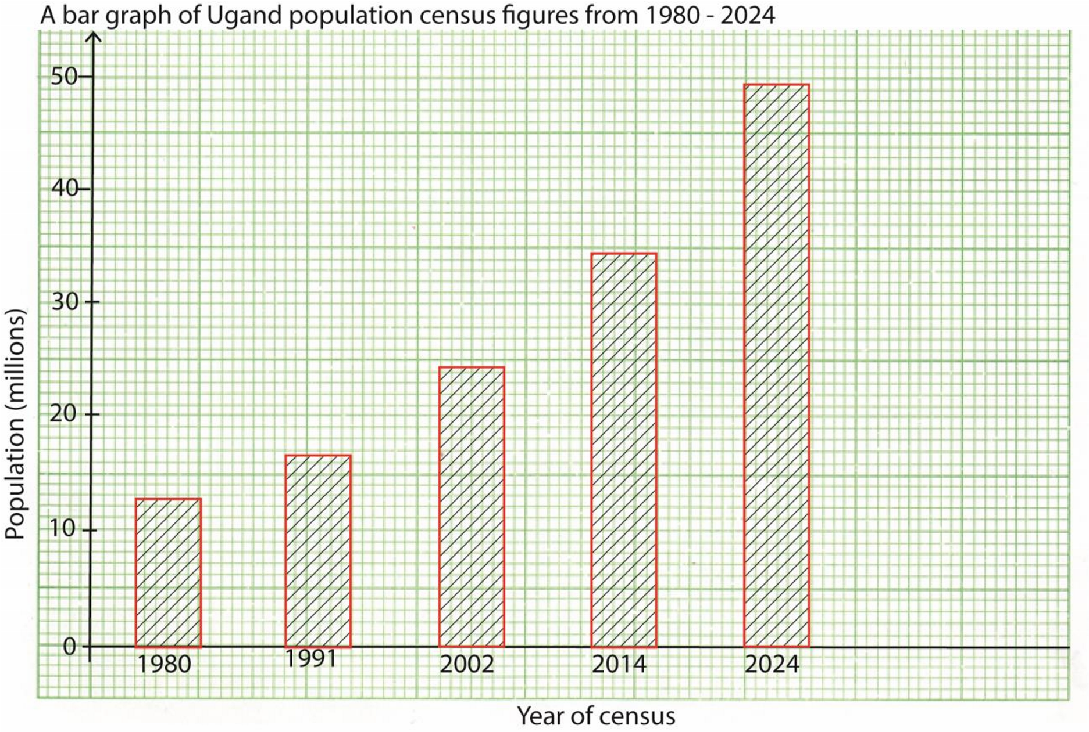
Trends and patterns in population growth rate of Uganda between 1980 and 2024
- Steady growth: Uganda’s population has nearly quadrupled in 45 years.
- Acceleration in 1990s–2000s: Growth rate peaked around 3.5% annually.
- Youthful structure: Over 50% of Ugandans are under 18, fueling continued growth.
- Urbanization: Kampala–Wakiso corridor shows the fastest expansion, while Karamoja remains sparsely populated.
Factors Driving Growth of Uganda
- High fertility rates: Around 5 children per woman in recent decades.
- Declining mortality: Improved healthcare, immunization, and maternal-child survival.
- Demographic momentum: Large youth cohorts sustain growth even as fertility slowly declines.
- Migration: Rural-to-urban migration increases city populations.
Positive implications of high populations growth of Uganda
- Large labor force: Uganda’s youthful population (over 50% under age 18) provides a growing workforce that can drive industrialization, agriculture, and services.
- Expanding domestic market: More people mean greater demand for goods and services, encouraging local production and attracting foreign investment.
- Demographic dividend potential: If fertility declines and education improves, Uganda could benefit from a favorable age structure where more people are working than dependent.
- Innovation and entrepreneurship: A youthful population often brings creativity, adaptability, and entrepreneurial energy, fueling new businesses and tech adoption.
- Cultural vibrancy and diversity: High population growth sustains Uganda’s rich cultural traditions and provides a dynamic social environment.
- Regional influence: A large population enhances Uganda’s geopolitical weight in East Africa, strengthening its bargaining power in trade and diplomacy.
Negative implications of high population growth of Uganda

(i) Pressure on land and agriculture
- Land fragmentation reduces farm sizes, leading to declining productivity.
- Overcultivation causes soil erosion and degradation, threatening food security.

(ii) Strain on social services
- Schools overcrowded, lowering education quality.
- Hospitals overstretched, limiting access to healthcare.
- Housing shortages fuel slums in Kampala and other towns.

(iii) Unemployment and underemployment
- Rapidly growing labor force outpaces job creation.
- Many youths turn to informal or precarious work, increasing poverty risks.

(iv) Urbanization challenges
• Kampala–Wakiso corridor faces congestion, poor sanitation, and inadequate transport. • Unplanned settlements expand, creating environmental and health hazards.

(v) Environmental degradation
- Deforestation for fuel and farmland.
- Wetland encroachment and water pollution. • Loss of biodiversity due to human pressure.

(vi) Regional inequality
- Central Uganda grows fastest, widening disparities with sparsely populated regions like Karamoja.
- Uneven development fuels migration and social tensions.
Population control measures in a developed country
Developed countries use voluntary, rights-based population control measures such as access to contraception, family planning education, incentives for smaller families, and policies that balance fertility with economic sustainability.
Common Population Control Measures in Developed Countries
- Access to contraception: Widespread availability of birth control methods (pills, IUDs, sterilization) ensures individuals can plan family size.
- Family planning education: Comprehensive sex education in schools and public campaigns promote informed reproductive choices.
- Healthcare systems: Universal healthcare covers reproductive health services, reducing unintended pregnancies.
- Legal frameworks: Laws support reproductive rights, safe abortion access, and gender equality in decision-making.
- Economic incentives: Tax benefits or subsidies encourage smaller families, while in aging societies, policies may shift to support higher fertility.
- Immigration policies: Developed countries often balance low fertility with controlled immigration to sustain workforce size.

Practical birth control measures in developing countries like Uganda

In Uganda and other developing countries, practical birth control measures include widespread access to modern contraceptives, family planning education, adolescent reproductive health programs, community outreach, and supportive government policies.
- Modern contraceptives: Pills, injectables, implants, IUDs, condoms, and sterilization are promoted through health centers. USAID and UNFPA ensure uninterrupted supply chains for contraceptives.
- Family planning education: Community health workers and NGOs like Pathfinder International run awareness campaigns. School-based programs teach adolescents about reproductive health.
- Adolescent reproductive health programs: Nearly 1 in 4 Ugandan girls aged 15–19 is pregnant or already a mother. Youth-friendly clinics and peer education groups provide counseling and contraceptives.

(iv) Government policies: Uganda’s Family Planning Costed Implementation Plan II (2020/21–2024/25) sets national targets for contraceptive uptake and aligns with SDGs.
(v) Community outreach: Village health teams distribute contraceptives and educate households. Religious and cultural leaders are engaged to reduce stigma around family planning.
Population Structure
A population structure is the composition of a population in terms of age, sex, and other demographic characteristics. It shows how people are distributed across different age groups and genders, often visualized using a population pyramid.

Features of Uganda’s Population Structure

(i) Age distribution:
- Over 50% of Ugandans are below 18 years. o Median age is 16.9 years, among the lowest globally.
- Only about 3% are aged 65+, showing limited elderly population.

(ii) Sex ratio:

o 2024 census recorded 22.5 million males and 23.4 million females, giving a sex ratio of 96 males per 100 females.

(iii) Households:
- Average household size is 4.4 persons.
- Total households: 10.8 million in 2024.

(iv) Fertility and mortality:
- Fertility rate ≈ 4.7 children per woman (still high compared to global averages).
- Declining infant and child mortality due to improved healthcare.

(v) Urbanization:
- About 26% of Ugandans live in urban areas, with Kampala–Wakiso corridor being the fastest growing.
- Rural areas remain dominant, but migration to towns is accelerating.
Implications of Uganda’s population structure
Uganda’s population structure is very youthful, with over half the population under 18 and a median age of 16.9 years. This creates opportunities for a large labor force and market growth, but also challenges such as high dependency ratios, pressure on resources, and unemployment.
Key Implications of Uganda’s Population Structure
- High dependency ratio: With more than 50% of Ugandans below 18, the working-age population supports a large number of dependents. This strains household incomes and government budgets for education and healthcare.
- Potential demographic dividend: If fertility declines and investments in education, skills, and jobs increase, Uganda could benefit from a favorable age structure where more people are productive than dependent.
- Pressure on education and health services: A youthful population requires massive investment in schools, teachers, and healthcare facilities. Overcrowded classrooms and overstretched hospitals are common challenges.
- Urbanization and infrastructure demand: Rapid growth in urban centers like Kampala– Wakiso corridor creates housing shortages, traffic congestion, and sanitation issues.
Infrastructure expansion is critical to absorb this growth.
- Employment challenges: Each year, hundreds of thousands of young Ugandans enter the labor market. Job creation lags behind, leading to youth unemployment and underemployment.
- Environmental stress: High population growth accelerates deforestation, wetland encroachment, and soil degradation as land is subdivided and overused.
- Regional inequality: Central Uganda grows fastest, while northern and Karamoja regions remain sparsely populated and underdeveloped. Uneven distribution fuels migration and social disparities
Population Migrations
Migration is the process by which people leave their usual place of residence to settle in a new location, temporarily or permanently.

Types of Migration:
- Internal migration: Movement within the same country (e.g., rural to urban migration in Uganda).
- International migration: Movement across national borders (e.g., Ugandans moving to Kenya or the Middle East for work).
- Voluntary migration: People move by choice, often for jobs, education, or better living conditions.
- Forced migration: People are displaced due to conflict, natural disasters, or persecution.
- Seasonal migration: Temporary movement linked to agriculture, tourism, or climate.

Duration:
The UN defines a long-term migrant as someone living outside their country of origin for at least 12 months.
Causes of migration
Migration is driven by a mix of economic, social, political, and environmental factors. People move to seek better opportunities, escape hardships, or reunite with family.
- Economic opportunities: People migrate to find jobs, higher wages, or better living standards. For example, rural–urban migration in Uganda is fueled by the search for employment in Kampala.
- Education: Students move to cities or abroad to access better schools, universities, and training opportunities.
- Social factors: Family reunification, marriage, or cultural ties often motivate migration.
- Political instability: Conflict, persecution, or poor governance can force people to leave their homes. Refugees and asylum seekers are examples of politically driven migration.
- Environmental changes: Natural disasters, droughts, floods, and climate change push people to relocate to safer or more fertile areas.
- Healthcare access: People may migrate to regions with better medical facilities and services.
- Poverty alleviation: Migration is often seen as a way to escape poverty, with remittances sent back home supporting families.
Positive Effects of Migration
- Economic growth: Migrants provide labor in receiving countries and send remittances home, supporting families.
- Cultural diversity: Migration enriches societies with new traditions, languages, and cuisines.
- Skill transfer: Migrants bring new knowledge and skills, improving productivity. (iv) Population balance: In aging societies, migration helps sustain the workforce.
Negative Effects of Migration
- Brain drain: Skilled workers leaving developing countries weaken local economies.
- Urban overcrowding: Rapid migration to cities causes congestion, slums, and strained infrastructure.
- Social tensions: Cultural differences may lead to discrimination or conflict.
- Pressure on services: Receiving areas face increased demand for housing, healthcare, and education.
- Environmental stress: Migration can accelerate deforestation, pollution, and land use changes.
Policies of Uganda on migration

Uganda has adopted a National Migration Policy (2025) to manage internal, regional, and international migration. It emphasizes poverty reduction, national development, refugee protection, labor migration regulation, diaspora engagement, and regional integration.
Key Policies of Uganda on Migration
- National Migration Policy (2025): Uganda’s first comprehensive migration framework, designed to coordinate migration management for development.
- Refugee protection: Uganda hosts over 1.9 million refugees, one of the largest refugee populations globally. Policies guarantee freedom of movement, access to land, education, and healthcare.
- Labor migration regulation: Policies regulate Ugandans working abroad, especially in the Middle East, to protect them from exploitation and ensure safe recruitment practices.
- Irregular migration control: Measures to combat human trafficking, smuggling, and undocumented migration, with stronger border management.
- Diaspora engagement: Policies encourage Ugandans abroad to invest back home, send remittances, and contribute skills to national development.
- Regional integration: Uganda supports free movement of persons within the East African Community (EAC) and IGAD region, aligning with regional treaties.
Uganda policies on population

(i) Uganda’s population policies focus on managing rapid growth, promoting family planning, improving health and education, and harnessing the demographic dividend for sustainable development.
(ii) Key Population Policies in Uganda

(iii) National Population Policy (2008, revised 2020): Recognizes population as Uganda’s most important resource. It emphasizes family planning, reproductive health, gender equality, and education as tools to manage growth.
- Demographic Dividend Roadmap (2018): Aims to shift Uganda’s age structure by reducing child dependency and increasing the working-age population. Focuses on keeping girls in school, improving child survival, and expanding family planning.
- Vision 2040: Uganda’s long-term development plan links population management to economic transformation. It stresses mindset change, skilling, and digital transformation to turn population growth into wealth creation.
- Family Planning Costed Implementation Plan (FP-CIP II, 2020/21–2024/25): Sets targets for contraceptive uptake, aiming to reduce unmet need for family planning and lower fertility rates.
- State of Uganda Population Reports (annual): Provide updates on population trends, challenges, and policy directions. The 2023 report emphasized mindset change for a favorable age structure as key to wealth creation
Possible solutions to the population problems in developing countries
The solutions aimed at solving the problems of increasing population are contained in the population policy. Therefore the population policy is aimed at attaining optimum population by checking on population growth and increasing resources and production capacity. Such population policies include the following;
- Family planning. This includes the use of contraceptive pills, condoms and other intrauterine devices. However, this method has not been effectively used due to high levels of illiteracy and fear of side effects.
- Encouraging higher education. Emphasis should be put on female education so as to check on the fertility rates and emphasize the quality of children other than the quantity. In addition, education also helps to postpone marriages for the future.
- Adopting production policies aimed at increasing food supply to reduce on food shortages. This helps to reduce on the diseases associated with malnutrition.
- Rural development policies aimed at making rural areas attractive so as to check on rural urban migration. Such policies include rural electrification, security, water supply etc. This also promotes agricultural production.
- Disease control measures. Health programs should be set up to educate the people on how to control and reduce on the spread of diseases through primary health care.
- Legalizing abortion as a way of controlling unwanted pregnancies and population growth.

TOPIC 2/3: Drainage and the Role of Rivers in Shaping the Landscape
Competency: The learner devises sustainable ways of harnessing drainage features and related resources for development through analysing their nature and impact on landscape, ecosystems, and human activities.

The drainage System of Uganda
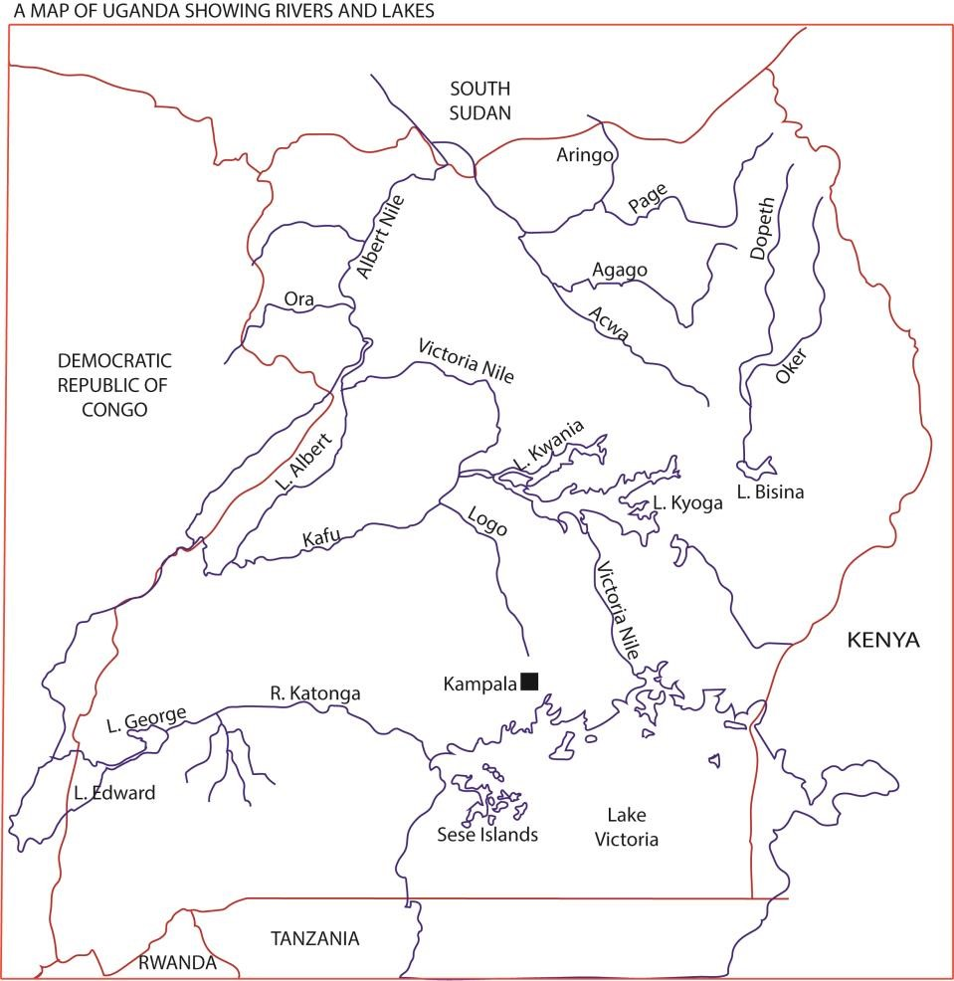

Key Drainage Features in Uganda
- Lake Victoria: The largest lake in Africa, forming Uganda’s southern boundary. It’s the source of the Nile.
- River Nile: Flows northward from Lake Victoria through Lake Kyoga and Lake Albert, continuing into South Sudan.
- Lake Kyoga: A shallow lake in central Uganda, acting as a catchment for rivers draining into the Nile.
- Lake Albert: Receives water from Lake Kyoga via the Victoria Nile; part of the Nile system. • Lake Edward and Lake George: Connected by the Kazinga Channel, draining into Lake Albert.
- Major rivers: Include the Katonga, Kafu, and Semliki rivers, all feeding into the Nile system.

Evolution of Uganda’s Drainage system
Uganda’s drainage system evolved through tectonic movements, volcanic activity, and crustal warping that created basins for lakes and channels for rivers. The Nile system, especially the Victoria Nile, was shaped by these geological changes, linking Uganda’s major lakes into one interconnected drainage network.

(i) Tectonic and Crustal Movements
- Earth movements in East Africa caused depressions and basins that later filled with water.
- These movements created rift valleys and warped crustal basins, forming lakes such as Victoria, Albert, Edward, and George.
- The Rwenzori uplift diverted rivers and reshaped drainage patterns, forcing water into new basins.

(ii) Formation of Lakes
- Lake Victoria: Formed in a crustal depression, it became the largest freshwater lake in Africa.
- Lake Kyoga: A shallow basin lake, acting as a catchment for rivers draining into the Nile.
- Lake Albert: Receives water from the Victoria Nile and Kazinga Channel.
- Volcanic lakes in southwestern Uganda (e.g., Katwe, Bunyonyi) were formed by volcanic activity.

(iii) Development of the Nile System
- The Victoria Nile emerged as Lake Victoria’s outlet, flowing north into Lake Kyoga and then into Lake Albert.
- The Albert Nile continues northward into South Sudan, linking Uganda’s drainage to the wider Nile Basin.
- Over time, river capture and tectonic shifts redirected flows into this unified system.

(iv) Swamps and Wetlands
- Extensive swamps developed along rivers and lake shores, such as the Nabajuzi and Rubigi wetlands.
- These wetlands regulate water flow, filter sediments, and support biodiversity.

Lakes
A lake is a depression or basin filled with water
Lakes in East Africa differ in permanency, salinity, shape, size and depth.

Processes for formation of lakes
Lakes may be formed by
- earth movements such coastal warping, faulting and folding;
- vulcanicity,
- erosion and deposition
- landslides
- human activity

Formation of lakes by earth movements
- Coastal warping
The extensive downward and upward movement of the crust led to formation of depressions and uplands. Down warping occurred in central and South Eastern Uganda to form depressions occupied by lakes Victoria, Kyoga, Wamala and Nakivale.

  - Before warping took place, land in central Uganda was sloping to the West and rivers like Katonga, Kagera, Rwizi, Kafu were flowing to the west.
  - During warping, Eastern and Western Uganda were up warped while central Uganda down warped forming basins.
  - After warping, rivers reversed their flow eastwards; emptying their waters into the basins to form lakes Victoria and Kyoga. Diagram(s) to illustrate river flows

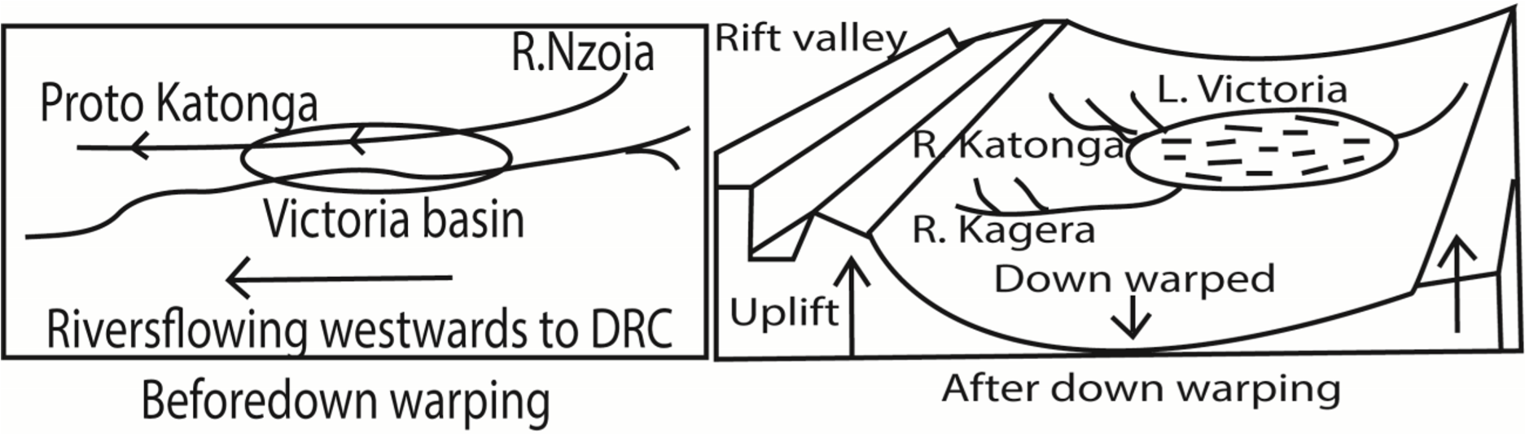
  - The formed lakes are shallow in depth, having fresh water, irregular outlines/shore lines and extensive swamps around them bays/headland.

- Faulting
The breaking and subsequent displacement of crustal rocks by forces of tension or compression led to the formation of following types of lakes:

  - Grabens
Grabens are hollow lakes/Rift valley lakes found in rift valley floor occupying graben hollow. Grabens result from forces of tension, compression forces. E.g. Albert, Tanganyika, Edward, George, Natron, Eyasi etc.
According to tensional forces
  - Radioactive and convective currents from the mantle caused lines of weakness.
  - Normal faults were created in the crust.
  - Displacement occurred in the crust forming the rift valley.
  - Secondary faulting took place in the rift valley to form grabens.
  - Formed grabens were later occupied by water to from rivers, rain to form lakes.

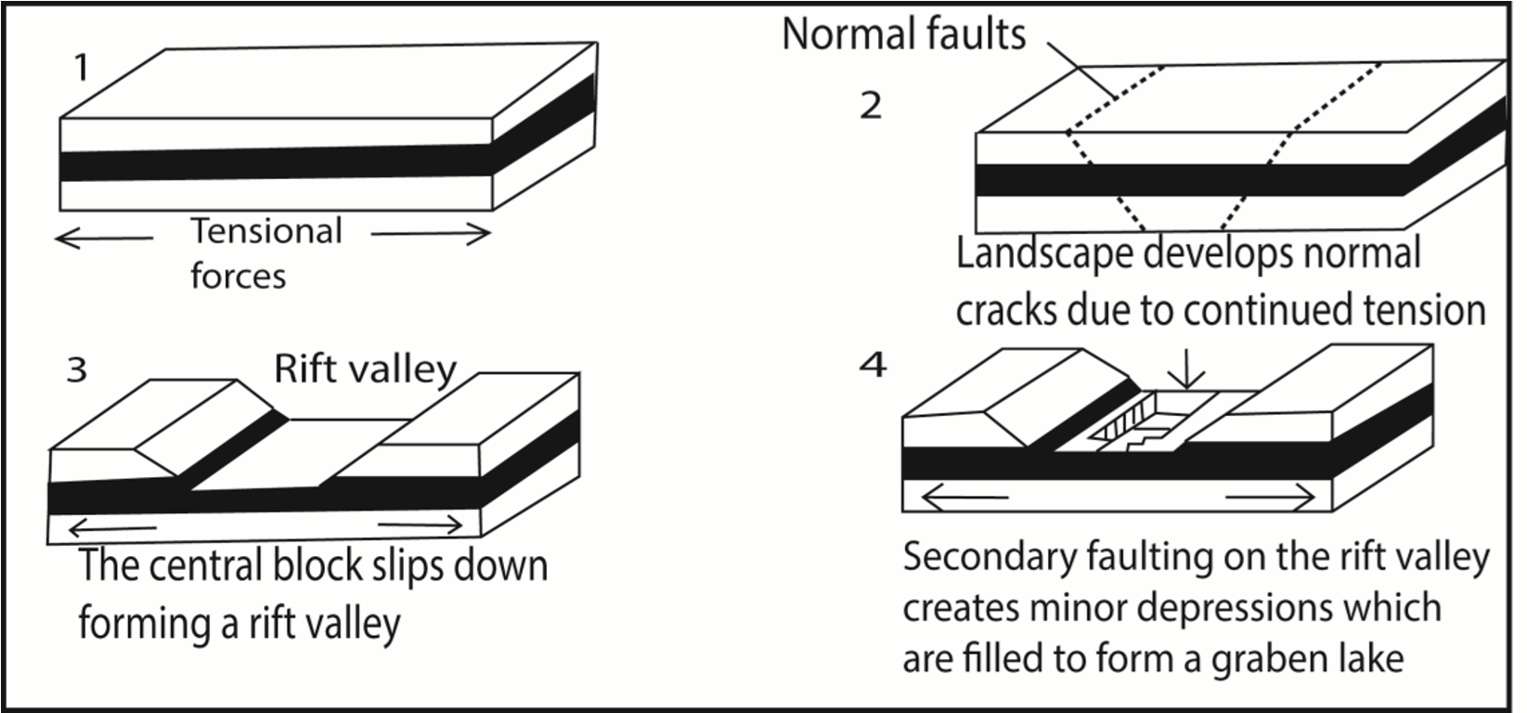
According to compressional forces
  - Radioactive and convective currents from the crust produced lines of weaknesses.
  - Reversed faults were formed in the crust
  - Crustal displacement occurred to form the rift valleys
  - Secondary faulting took place in the rift valley forming grabens.
  - The formed grabens were occupied by water from rivers, rain to form lakes.

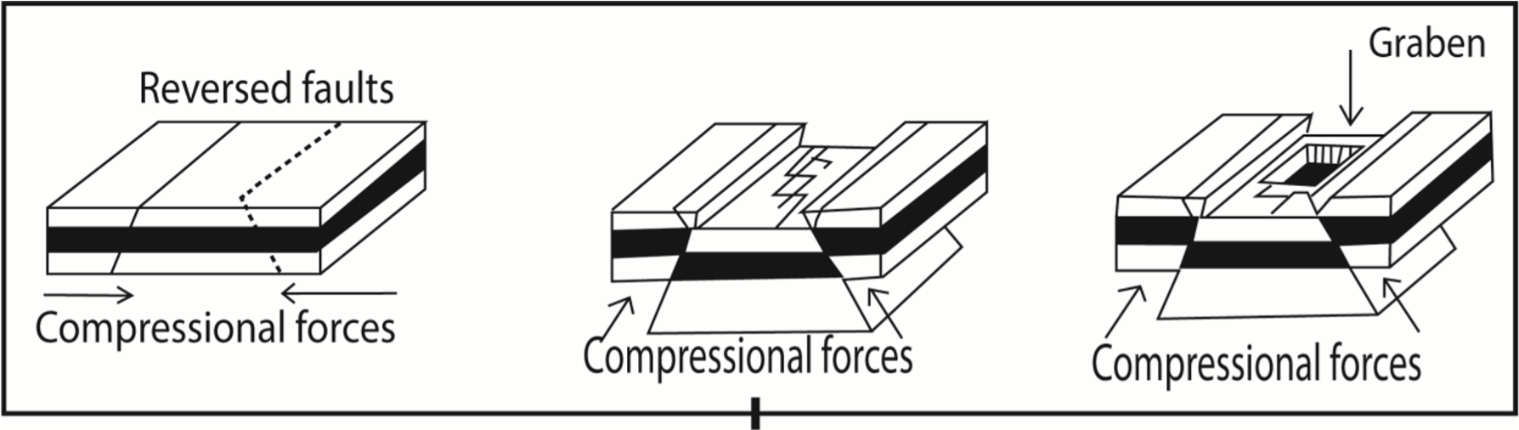
  - The formed lakes are characterized by being narrow, elongated and deep with steep bank, taking shape of the grabens.
  - Examples include lakes; Albert, Tanganyika, Turkana, Edward etc.

  - Tilt block lakes
Tilt block lakes occupy depressions between tilted uplands/ridges.
  - Tension and compression forces led to formation of several parallel faults dividing up the crust into several blocks.
  - Faulted landscape was then subjected to uplift or sinking at different rates and then tilting in one direction forming angular ridges and depressions.
  - Water from rain /rivers fill the depressions to form a lake(s) e.g. Lake olbolossat in Aberdares in Kenya.
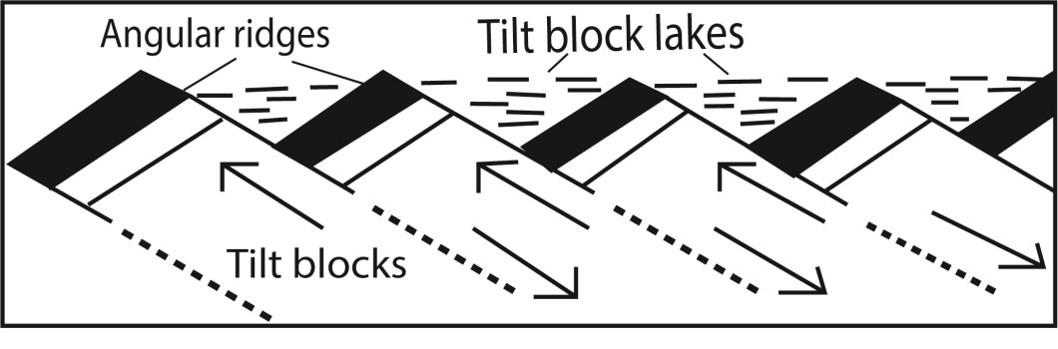

Formation of lakes by vulcanicity

These lakes are formed when volcanic eruption blew off the mountain tops leaving behind funnel shaped depressions. They include

- Crater lakes are formed due to eruption leaving behind depression/craters less than two miles. These are filled with water to form lakes Examples include L. Katwe, L. Nyamunuka, etc.

- Caldera lakes such as Ngorongoro in Tanzania and Longonot in Kenya are similar to crater lakes except that they bigger

- Lava lakes are formed when flowing lava from a volcano block a river valley leading to formation of lava dammed lake e.g. L. Muhehe, L. Bunyonyi etc.

Deposition lakes
These are formed as a result of erosion and subsequent deposition along the lower course of a river. They include
- Ox-bow lakes are horse-shoes shaped lakes or pool that forms when a wide meander of a river is cut off, creating a free-standing body of water. Examples are L. Makara on river Tana..
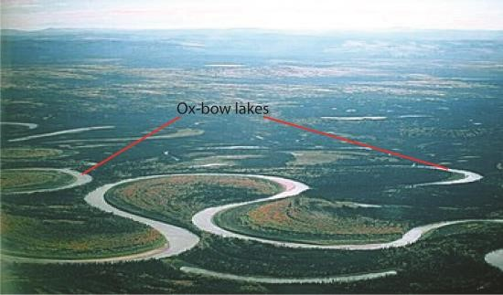

- Lagoons like L. Nabugabo are formed by wave deposition

- Delta lakes like L. Mchengu on R. Rufigi were formed when the river deposited excess alluvial that blocked some tributaries creating a small lake

Glacial lakes
These occupy cirques on high mountains of Rwenzori formed by glaciations process. The constant erosion caused by glaciers on this snowcapped mountain of the moon, shallow steep sided depression are created known as cirques. When these are filled with water, glacial tarns are formed. Examples include Lac du Speke, Lac Catherine, Lac Noir and Lac Vert all on slopes of Mt. Rwenzori in western Uganda.

Weathered/Solution lakes.
Chemical weathering act on some rocks especially limestone and make them break/dissolve. In such places large pits are created/formed. When the pits are filled with water small lakes known as solution lakes are formed like in Nyakasura south western Uganda.

Man- made lakes
These are dug by human e.g. Kabaka’s lake in Kampala

Lakes formed from by land slides
Landslides, avalanches and other waster debris form temporary barrier that dam and form temporary lakes, e.g. L. Mbaka which formed in Tanzania in 1955 across Mbaka valley

Importance of lakes
Positive importance of lakes
- Provide fish such as tilapia and Nile perch for human consumption and trade
- Provide water for irrigation
- Provide domestic water and animal consumption e.g. L. Victoria, L. Mburo etc.
- Provide fishing grounds
- Are used for transport . For example L. Albert link Butiaba in Uganda to Muhanga in Congo, L. Victoria connects Jinja and Port bell of Uganda to Mwanza in Tanzania and Kisumu of Kenya.
- Clay and sand along the shores are used for pottery and construction
- Papyrus vegetation from lakes like Kyoga are are used in making art crafts such mats and baskets that provide income to local communities
- Evaporation from lakes leads to formation of rainfall and modify climate of the surrounding areas.
- Promote tourism due to many plant and animal species they contain and beauty sceneries they provide e.g. Lake Bunyonyi.
- For extraction of mineral such salt from L. Katwe
- Lakes makes it possible for the generation of HEP like L. Victoria act as a reservoir for R. Nile where Owen falls dam and Bujagali dam are built. HEP in turn has led to industrialization in Jinja and Kampala for jobs and government revenue.
- Lake support growth of forests to surrounding areas that are source of wood for constructions and fuel
- Sand which is found at the shores of L. Victoria is used for construction purpose and glass making. Salt mining in L. Katwe, oil Prospects in Albert shores, clay mining in Kajjansi for ceramics on L. Victoria shores, all provide jobs to Ugandans, foreign exchange and infrastructure development.
- Lakes provide great opportunities for research and study purpose in relation to fisheries, forestry, navigation and soils. There is also a meteological department at Entebbe thus weather studies which all help Ugandans understand their environment and make proper planning especially in the farming sector.

Negative importance of lakes

- May lead to accidents such as drowning of fishermen.
- Lakes are barriers to construction of transport networks of roads and railway. For instance L. Bunyonyi has made some parts of Kabale remote and backward. The low levels of infrastructure in such areas lead to low trade development and low Uganda’ s development.
- The swampy vegetation on crescents of lakes like Kyoga are breeding grounds for dangerous pests like mosquitoes and tsetse flies. Such pests transmit human diseases such as malaria and sleeping sickness respectively to people in Lwampanga on Kyoga.
- Sometimes lakes over flood their shorelines and this leads to property destruction and loss of lives. For instance L. Bisiina flooded in 2007 causing water borne diseases to people in the area.
- Lakes that are shared by different countries like Albert and Edward by Uganda and Congo, Victoria by Uganda, Kenya and Tanzania, cause conflicts especially during usage of the lake in fisheries, transport and mining as it was between Uganda and Kenya over Mijingo island and on Albert with Congo.
- The changes in water levels lead to submergence and emergence of water which leads to destruction of ports as it has been on L. Albert.
- Some lakes like Albert and George fault lakes have got saline water and fault scarps along their shoreline which discourage fishing activities hence low development of the fishing industry.
- Lakes also harbour dangerous wild animals such as snakes, crocodiles and hippos which destroy crops and claim people’ s lives like in L. Albert and Edward. Revision exercise 1

- (a) Asses the influence of vulcanicity on lake formation in East Africa (b) Explain the importance of lakes in East Africa.
  - candidate should define and explain the origin of vulcanicity; should define a lake and then explain how lakes are formed by vulcanicity; a candidate should the evaluate the question by giving other process through which lakes are formed. Marks are always awarded for an evaluation showing your stand points to a big extent or small extent. Finally explain the positive and negative importance of lakes)
- To what extent has faulting been responsible for formation of lakes in East Africa?
  - candidate should define a lake and then explain how lakes are formed by faulting; then evaluate the question by giving other process through which lakes are formed.)

- To what extent have down warping influenced lake formation in East Africa

  - candidate should define a lake and then explain how lakes are formed by down warping; then evaluate the question by giving other process through which lakes are formed.)
- Discuss the formation of Kyoga basin and examine the economic viability of the lake to the region where it is located.
(Approach Define a lake. Identify where Lake Kyoga is found and some of the landing site on the lake. Locate the lake differently shaded on the map of Uganda with other lakes. Make sure you indicate its landing sites. With aid of diagrams explain its formation. Explain with examples the positive and negative importance of the lake MAJORY to the region where it is located.)

Rivers
River is a mass of water flowing over land through a defined and specific direction. Uganda is drained by various rivers almost the entire landscape of the country. They are majorly nine rivers which include;
- R. Nile which include Victoria Nile and Albert Nile. It has its source in L. Victoria and its mouth in Mediterranean Sea.
- R. Katonga which flows from L. George to L. Victoria.
- Mpologoma-Manafa River, which originates from Mt. Elgon to L. Kyoga.
- Mayanja-Kato River, which has its source in L. Victoria and its mouth into Kafue.
- Aswa-Moroto River, it originates from north eastern Karamoja areas to R. Nile.
- R. kafue which originates from L. Kyoga to L. Albert.
- R. Kagera, it originates from Rwanda hills to L. Victoria.
- Depeth-Okoth which originates from Karamoja hills to Kyoga.

Processes that lead to formation of rivers in Uganda
Rivers in Uganda are formed mainly through tectonic movements, volcanic activity, glacial processes, rainfall and surface runoff, and river capture. These processes created basins, channels, and slopes that direct water flow into Uganda’s interconnected drainage system dominated by the Nile.
Key Processes Behind River Formation in Uganda
- Tectonic movements: Crustal warping and rifting in the East African Rift created depressions and basins. These depressions became lakes (Victoria, Albert, Edward, George), which serve as sources of rivers like the Nile and Semliki.
- Volcanic activity: Explosive eruptions in southwestern Uganda formed crater lakes (e.g., Katwe, Bunyonyi). Rivers developed as outlets from these volcanic basins, draining into larger systems.
- Glacial and erosional processes: In the Rwenzori Mountains, glaciers and erosion carved valleys. Meltwater and rainfall created rivers such as the Semliki, which flows into Lake Albert.
- Rainfall and surface runoff: Uganda’s equatorial climate provides abundant rainfall. Water collects in channels, forming rivers like Katonga and Kafu that drain into Lake Victoria and Lake Kyoga.
- River capture: Shifts in drainage patterns caused by tectonic uplift redirected flows. For example, the Victoria Nile was captured as Lake Victoria’s outlet, linking it to Lake Kyoga and Lake Albert.

Comparison of the map of ancient drainage (before Pleistocene period) and the map of present drainage system of Uganda

Ancient Drainage (Before the Pleistocene Period)
- Orientation: Rivers flowed westward into the Congo Basin rather than northward into the Nile.
- Lake Victoria: Did not exist in its present form; the area was a broad swampy depression.
- Rwenzori uplift: Had not yet fully diverted rivers, so drainage patterns were different.
- Semliki River: Acted as a major outlet toward the Congo Basin.
- Endorheic basins: Some depressions trapped water locally without outlets, forming small lakes and swamps.

Present Drainage System (Post-Pleistocene to Today)
- Lake Victoria: Formed as a large tectonic basin, now the source of the Victoria Nile.
- Victoria Nile: Flows north into Lake Kyoga, then west into Lake Albert, continuing as the Albert Nile into South Sudan.
- Kazinga Channel: Connects Lake Edward and Lake George, draining into Lake Albert.
- Semliki River: Still flows into Lake Albert but now part of the Nile system.
- Overall orientation: Drainage shifted toward the Nile Basin, integrating Uganda’s lakes and rivers into one system.

and Present Drainage System (Post-Pleistocene to Today) of Uganda
Comparison Table

Feature

Ancient Drainage (Pre
-
Pleistocene)

Present Drainage (Today)

Main flow
direction

Westward into Congo Basin

Northward into Nile Basin

Lake Victoria

Swampy depre
ssion, not a major
lake

Largest freshwater lake, source of
Nile

Rwenzori uplift

Not fully developed

Diverted rivers into Nile system

Semliki River

Major westward outlet

Flows into Lake Albert, part of Nile

Integration

Fragmented basins, local swamps

Uni
fied Nile drainage system

Possible causes of difference of the Ancient Drainage

system

(
Before the Pleistocene Period)
- Tectonic Uplift and Warping: Movements of the Earth’s crust created new basins and tilted land surfaces which were filled with water to form lakes and rivers. While the Rwenzori Mountains uplift diverted rivers that once flowed west into the Congo Basin, redirecting them toward the Nile Basin.
- Formation of Rift Valleys: The East African Rift system caused depressions that filled with water, forming lakes such as, Albert, Edward, and George.These lakes became new sources and connectors for rivers, altering drainage directions.
- Volcanic Activity: Explosive eruptions in southwestern Uganda created crater lakes (e.g., Katwe, Bunyonyi).These volcanic basins changed local drainage patterns, feeding into larger systems.
- River Capture: Shifts in drainage boundaries caused rivers to be “captured” by new outlets. Example: Lake Victoria’s waters were captured by the Victoria Nile, linking it to Lake Kyoga and Lake Albert, and ultimately to the Nile.
- Climatic Changes (Pleistocene Ice Ages): Variations in rainfall and glaciation influenced water levels and flow directions. For instance glacial melt from the Rwenzori Mountains contributed to new river systems like the Semliki.
- Sedimentation and Wetland Development: Over time, sediment deposition reshaped channels and created wetlands, stabilizing the present drainage system.

The Role of Rivers in Shaping the Landscape
Rivers shape landscapes through erosion, transportation, and deposition, carving valleys, creating floodplains, forming deltas, and constantly reshaping the terrain as they flow from source to mouth.

Summary of the Role of Rivers in Landscape Formation
- Erosion: Rivers wear away rock and soil through hydraulic action, abrasion, and solution.
This creates features like V-shaped valleys, waterfalls, and gorges.
- Transportation: Rivers carry sediments (sand, silt, clay, pebbles) downstream. The load is moved by traction, saltation, suspension, and solution.
- Deposition: When rivers lose energy, they deposit sediments, forming floodplains, levees, deltas, and oxbow lakes.
- Meandering: In their middle and lower courses, rivers bend and curve, creating meanders and eventually oxbow lakes when loops are cut off.
- Landscape evolution: Over time, rivers transform rugged terrain into smoother plains, influencing ecosystems, agriculture, and human settlement.

Cross profile of a river
It is a section showing the vertical shape of a river from one bank to another. It defines in terms of width of a river valley. It is characterized by the following: it’s narrow in the youthful stage and wide in the old stage. This is because in the youthful stage there is more vertical erosion than lateral. While in the old stage there more lateral erosion than vertical hence the valley is widened. It’s V-shaped in the youthful stage and U-shaped in the old stage. The youthful stage is deep while the old stage is shallow
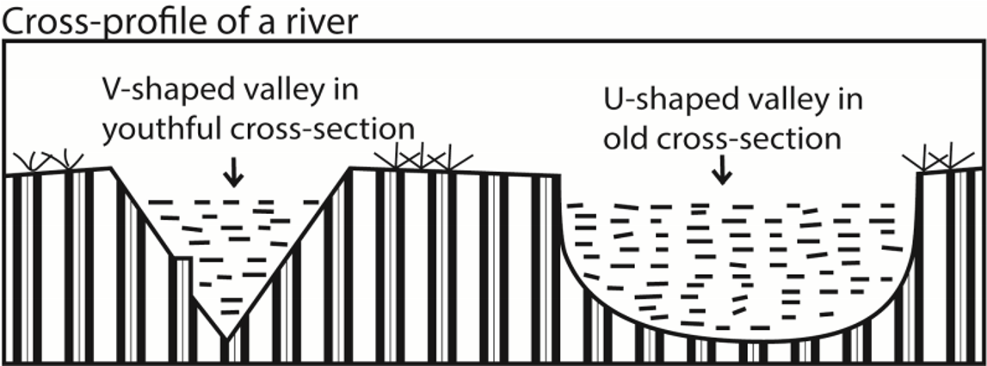

Long profile of a river
It is a section showing the slope of a river from its source to its mouth. It’s is defined in terms of distance covered by a river. It has three stages: youthful, mature and old stage.

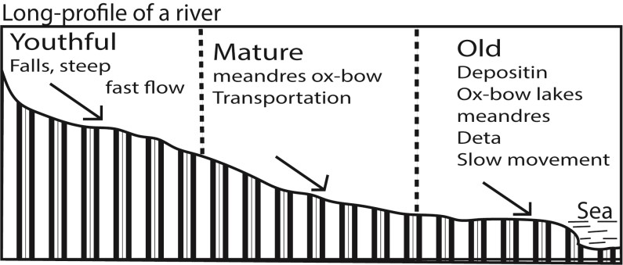

The youthful stage is characterized by:
- a very fast speed of river flow,
- high volume of water,
- the river has a steep gradient.
- The rivers’ cross-profile consists of a deep narrow V-shaped valley. - The river tends to wind within interlocking spurs.
- Vertical erosion is dominant over lateral erosion
- Numerous rapids, waterfalls, gorge, potholes, interlocking spurs and plunge pools The mature stage characterized by
- Moderately steep slope
- The river channel is U-shaped
- moderate speed of river flow
- Lateral erosion removes interlocking spur.
- Meanders and river bends begin to develop

The old stage characterized by
- Very gentle slope
- Deposition occurs
- Very slow speed
- Wide valley
- Meanders, bluffs, slip-off slopes, ox-bow lakes and alluvia’s fans formed

Reasons for nonexistence of a graded profile among rivers e.g. River Nile
A graded profile refers to well-developed concave slope from a river’s source to the mouth. It is sometimes referred to as a profile of equilibrium. Rivers try to attain a smooth river profile which is neither steep nor gentle by undermining highlands and eroding away obstacles while at the same time depositing the eroded sediments from upslope into the valley so as to attain a graded profile. However no river in East Africa Not even the Nile has attained a graded profile.

Reasons for non-existence of a graded profile along R. Nile
- Faulting within the river course. Faulting along the Karuma led to an increase in the erosion power of the Nile. This led to creation of a waterfall and depression (plunge and pool) thus a graded profile not formed
- Changes in climate. River Nile flows through an area with different climatic characteristics. Such regions are characterized by heavy rain at the source (Jinja - L. Kyoga) and low rains towards the middle and old age. Such differences interfere with development of a graded profile.
- Influence of river rejuvenation. When a river renews its erosion power there is increased erosion of the channel both vertically and laterally. The Nile has under gone rejuvenation at a number of stages for example around Karuma falls due to uplift it flows into a valley thus it’s speed is increased leading to the formation of potholes, plunge pool which interferes with development of smooth graded profile.
- Change in the base level. Base level is the lowest point below which a river cannot erode. It is an imaginary line extending from the river mouth beneath the land whose altitude is zero. The sea is the universal base while lakes are the local base level. R. Nile crossed Lakes Kyoga and Albert whose base level changes due to a rise/fall in water level due to climatic factors. Such changes interfere with the formation graded profile. Example when the base level falls, the river gains momentum and so does more erosion; when it rises, the gradient of the river reduces leading to a reduction in the river’s velocity hence deposition occurs.
- Differences in rock hardness. Soft rocks are easily eroded to form a wide and deep river channel. On the other hand rocks tend to resist a rivers erosive ability. Since R. Nile passes through a region with different hardness it has not been able to attain a graded profile. For example rapids at Jinja resisted erosion and remain protruding on the river bed.
- Presence or absence of vegetation and other obstacles. The presence of vegetation and hard volcanic Islands at Jinja between the ‘source’ of the Nile and Bujagali falls has led to braiding of R. Nile. Such circumstances have tampered with evolution of a graded profile.
- River capture. When a river arrests the waters of another adjacent river the energy of the capturing river is increased this leads to increased down cutting/erosion at the point of capture. This destroys a graded profile. The Nile captured river Tochi, Okole and Arocha thus an increased in its erosive power
- Human activities. Human activities like dam construction and irrigation tampers with the development of a graded profile. For example construction of dam like Nalubale and Kiira dams increase deposition upstream and erosion down stream

Landforms resulting from river erosion and deposition along a long profile of a river The features formed depend on the stage of a river

The erosional features formed in the youthful stage include gorge, waterfall, plunge pool, pot holes and interlocking spurs.

(a) Gorge/canyon
A Gorge/canyon is a deep narrow V-shaped river channel (valley) with high vertical walls. It’s formed by vertical erosion in an area of relatively resistant rocks when a river flows at a very fast speed. Gorges tend to wind between interlocking spurs of highlands e.g. there is gorge near Murchison Fall on R. Nile. Other examples include the Manambolo gorge in Malagasy and the fish river canyon (gorge) in Namibia and Mitano gorge through which R. Birira flows
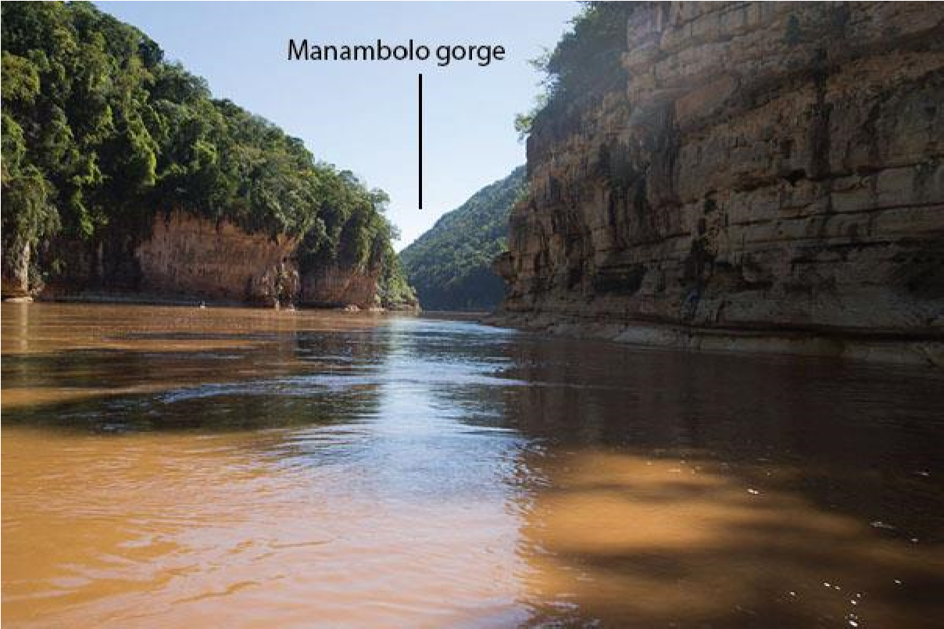

Conditions for formation of a gorge
- Vertical erosion due to rapid flow of river water over relatively resistant rocks like lime stone in youthful stage of the river
- River rejuvenation leading rejuvenation gorge where a river incises itself into the land surface due to a fall in base level e.g. Lupata Gorge along R. Zambezi
- Gorges may also be formed due to outflow cut by a river draining a lake e.g. Lower Congo Gorge near Kinshasha.
- Antecedent gorges are formed where a river has cut across a zone of rocks that are being slowly uplifted e.g. antecedent gorges along the Great Ruaha River in Tanzania
- Superimposed gorges are formed where a river is superimposed onto a zone of hard rocks from a former covering rock layer e.g. Sabaloka Gorge along River Nile in Sudan.
- Some gorges have been formed due to waterfalls retreating upstream e.g. Batoka Gorge below Victoria falls on R. Zambezi

(b) Waterfalls
Waterfall is a point in a river or stream where water flows over a vertical drop or a series of steep drops. Waterfalls are common in the upper course/youthful stage but can also occur in any part of the river profile. Some of the main water falls in Africa include Victoria Falls along river Zambezi, Murchison fall on River Nile and Sezibwa falls along River Sezibwa.

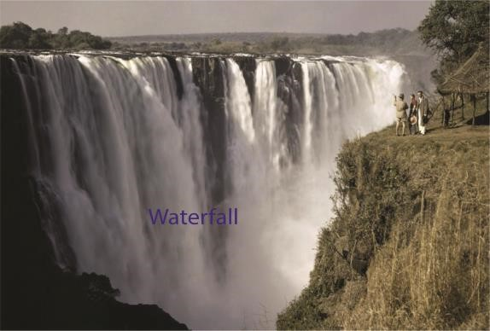

Causes/conditions for formation of waterfalls
- A sharp change in the resistance of rocks i.e. from a hard to soft rock. The hydraulic action of water massively erodes away softer rocks ahead of the hard rocks thus causing a change in gradient which forms a waterfall. Examples are Bujagali and Owen falls (Nalubale) or when there is an uplift of the land.
- Faulting across the river bed may lead to vertical displacement of rocks along the faultlines. In this case a river flows from high to a low elevation thus a waterfall.
Murchison fall along R. Nile was formed in this way.
- It is also formed where a larva barrier or landslide cross a river where it may initially form a lake. Then a water fall is likely to form at the over pill from the lake where the river drops over the edge of the barrier e.g. Lily falls in Madagascar is formed this way.
- Waterfalls may also be formed at the point where the river enters the sea at cliff line. A fall may develop near the mouth of a river if wave erosion out backs the cliff face or where the sea level has fallen. Examples occur in Cameroon Lobe river where Lobe falls were formed when it plunges over directly into the sea.
- Waterfalls may also be formed due to river rejuvenation at the knick point

Importance of water falls
These can be positive or negative
Positive importance
- Potential for HEP generation e.g. Bujagali and Owen falls along R. Nile in Uganda.
- Tourist attraction due to beautiful scenery formed e.g. Murchison falls
- Sporting and recreation
- Study purpose
Negative importance
- Lead to hindrances in navigation e.g. on river Nile
- Hindrance in fishing

(c) Plunge pool
Plunge pool is a hollow or broad depression formed at the base of a waterfall. Or an enlarged pothole at the base of a waterfall due to the progressive drilling and grinding of the valley floor by the hydraulic erosion and abrasive action of water. It’s found on rivers with waterfall in the youthful stage and along the rejuvenated section of a profile.
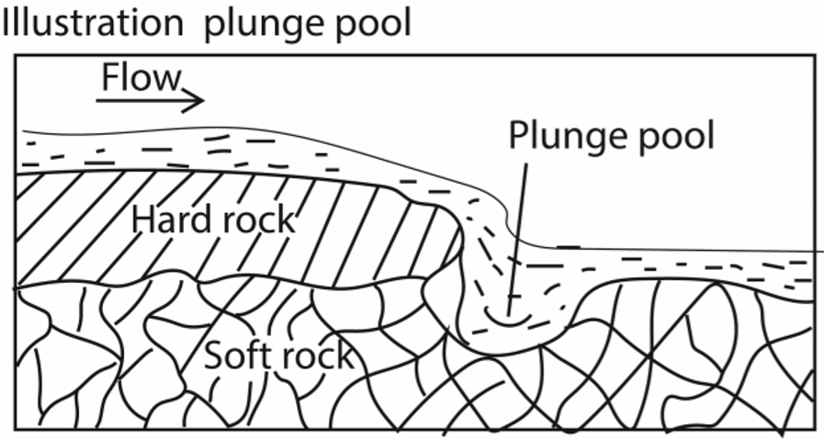
Plunge pool is formed under the following conditions.
- Large volume of water which increases the rivers’ competence.
- Steep gradient resulting into high erosive power of the river due to increased velocity.
- Large amount of abrasive tools like pebbles and boulders to grind the bed
- Difference in rock resistance in the river’s flow from a hard rock to soft rock thus drilling deeper underground.
Plunge pools are found along sezibwa falls, Ssipi falls, Kisizi falls and upper Tana river.

(d) Potholes
Potholes are circular depressions on the river bed. They are formed by swirling action of water along the river bed. The uneven bed of a fast flowing river cause the water to swirl (forward circular rotation). The pebbles carried by the river will start cutting circular depression which are gradually enlarged and deepened to form potholes.

(e) Interlocking spurs
Interlocking spurs are characteristic features of river flowing in a highland area. When a river flows through a series of highlands it tends to twist and turn around in the bid to avoid resistant obstacles. The river erodes the softer concave banks deposits on the relatively hard convex banks thus producing spurs on the either sides of the river. The deeply eroded concave banks stand up as Cliffs while deposition on the convex bank produces gently sloping extensions called slip off slopes. Examples of interlocking spurs are found on Mt.
Rwenzori along R. Mubuku and river Nile between the source and Bujagali falls.
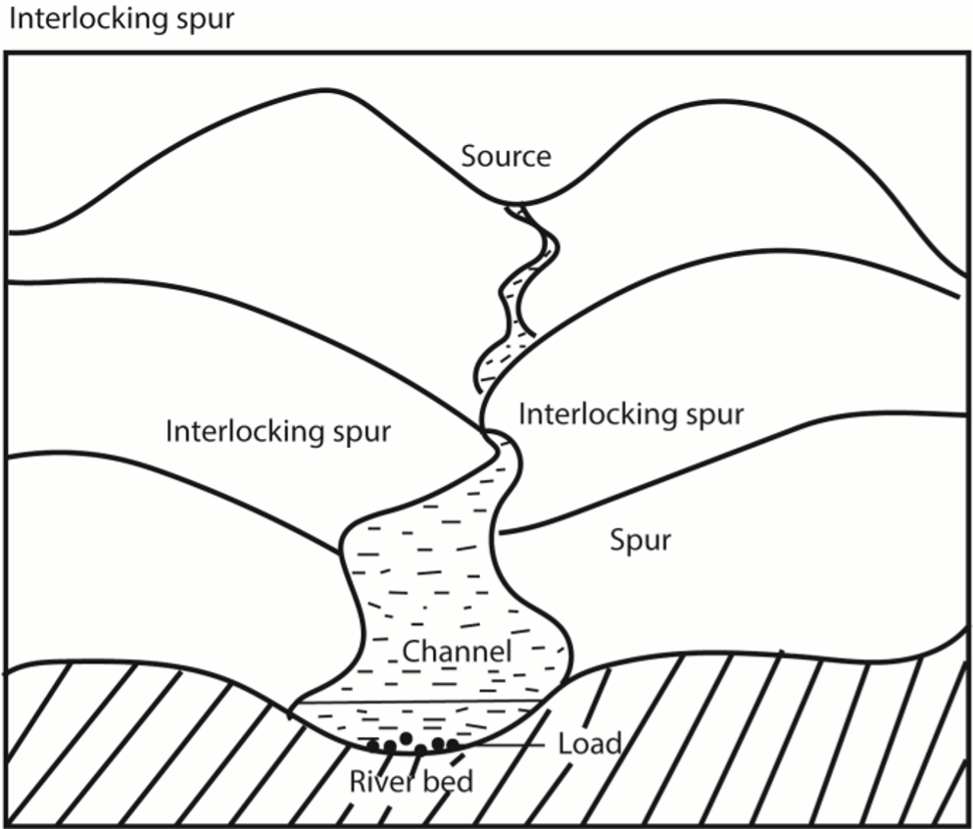

The erosional features formed in the mature/middle stage include meanders, Bluffs or cliffs

(f) Meanders
Meanders are curved bends of a river channel.
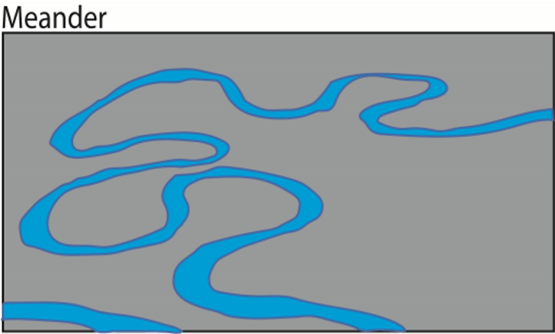

Conditions for formation of meanders
- They are formed in the middle and lower/old stages of a river due to a decrease in gradient leading to reduction in speed of the river and river competence.
- Meanders may occur when a river avoids an obstacle or hard rock.
- Presence of large and excessive load within the river. When such loads are deposited along river bends, it begins to meander.
- Reduced competence
- Erosion of the concave sides causes cliffs while the deposition on the convex side cause slip-off slopes. The occur on R. Rwizi, Semuliki, Mpanga and R. Ngaila on the Kano plain

Theories that explain development of meanders

- Reduced gradient along the river’s bed leads to reduced speed of the river. Once the speed is reduced the river energy reduces leading to deposits in the valley.
Accumulation load causes the river to meander.
- Siltation along the river reduces the gradient causing the river to look for steeper gradient creating bends
- The existence and occurrence of hollows and shallow sections on the river floor i.e. pools and rifles that encourage meanders.
- Presence of alternate soft and hard rocks; easy erosion of soft rocks relative to hard rocks encourages river meandering
- Meanders also develop to minimize time and energy

(g) Bluffs or cliffs
Bluffs or cliffs are also formed within the mature stage. Bluffs are cut Spur end that extended down into the river valley. They are formed when a river erodes laterally to widen its valley. The river erodes more its concave banks and eventually it shifts direction of flow towards the convex bank.
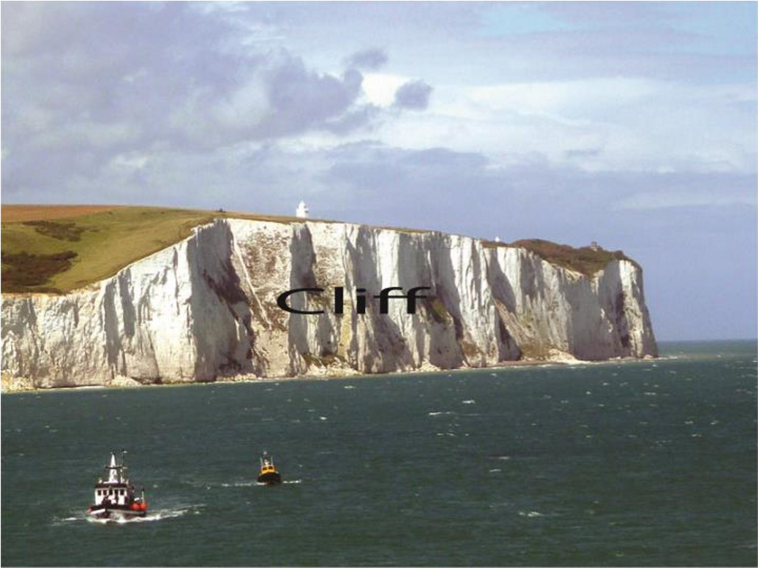

The erosional features formed in the old stage are Meanders, bluffs, slip-off slopes, flood plain, Levees, ox-bow lakes, deltas and Alluvial fans.

(h) Flood plain
A flood plain is gently is gently sloping plain of alluvium covering the valley floor down in which the river flows in a meandering channel. It’s usually flanked by ox-bow lakes formed along meander loops. Flood plains are formed when a river widens its valley by eroding on the concave bank and depositing on the convex bank. With time spur ends are cut thus widening the valley and depositing sediments in it.

Alternatively flood plains are formed when a river floods over its banks. The water spreads over the wide valley plain and sediment are deposited in the valley. Each time the river floods, and additional layer of sediments are deposited in the valley which later builds up the flood plain. Examples are found on R. Rwizi in Mbarara.

(i) Levees

Levees are raised ridges-like embankments composed of sediments on the sides of a river channel within the flood plain. They are formed when sediments a river deposits on the bank accumulate over a time due to continued floods. They may raise a few feet above the flood plain. Examples are found on R. Malaba and Yala and on Kano plain of Kenya.
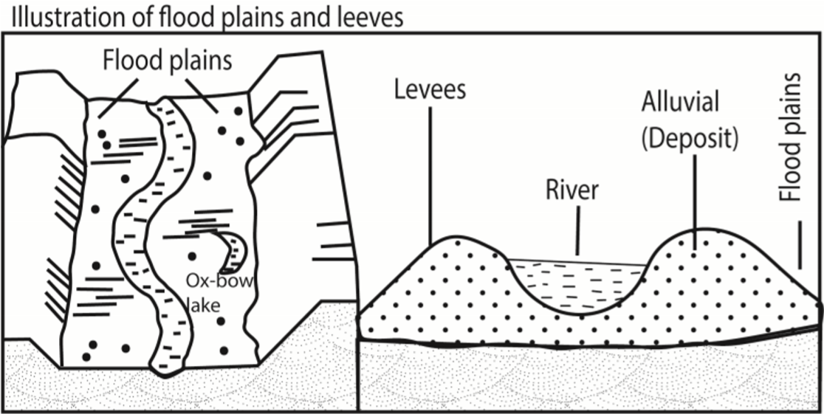

(j) Braided channel
A Braided channel is a wide shallow channel in which a stream, subdivides into a series of inter-connecting small channels separated by deposits. They are formed when a river carrying large quantities of load reduce its competence. This leads to deposition of the load on the river bed in series. Once these accumulate, they form sand bars which separates the river into numerous streams. But these streams later join to form a big stream. Examples are found on R. Nile between Malakal and Khartoum, R. Zaire, Kilombero and R. Tana.

(k) Alluvial fan
An alluvial fan is a triangle-shaped deposit of gravel, sand, and even smaller pieces of sediment, such as silt. They are formed when a mountain Torrent deposits its load at a point where it enters into a main valley. Examples are found on Kilombero valley on Mahenge and UChungwe highlands in Tanzania. In Uganda there is Lume fan on R. Lume on the Semuliki Valley.

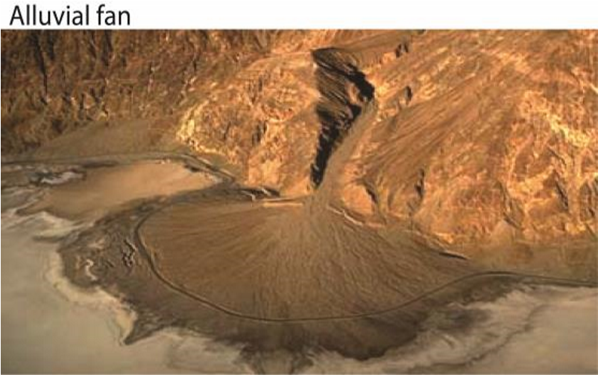

(l) Ox-bow lakes
Ox-bow lakes are horse-shoes shaped lakes or poo that forms when a wide meander of a river is cut off, creating a free-standing body of water. Examples are found on R. Semuli, R.
Rwizi, R. Tana, Ngaila, R. Nyando, Nzoia, Mkomazi and Rufigi in Tanzania.

(m) Slip-off slope
Slip-off slope is a gently sloping relief feature made up of deposits on the convex bank of a meandering river channel.
It’s formed as a result of a river depositing sediments eroded from the concave bank on to the convex bank. When a river erodes sediments from the concave bank it creates a steep wall on that bank called a cliff. While when it deposits the sediment on the convex bank, it creates a gently sloping relief feature called the slip-off slope. For example on the eastern side of R. Nile (Busoga) around the source at Jinja is the slip-off slope while the raised wall on the western side (Buganda) is a cliff. In this case the slip-off slope is made up of boulders
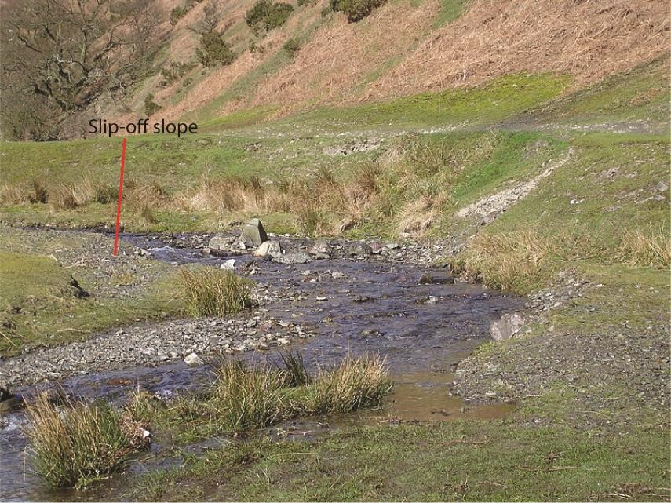
eroded from the concave bank.

(n) Wetlands
Wetland is a transitional area between terrestrial and aquatic eco-systems where the water table is usually at or near the surface or the land is covered by shallow water.

(o) Mouth of River
Mouth of River is the part of a river where the river enters into another river, a lake, a reservoir, a sea, or an ocean.

(p) Delta
A delta is a large flat/wetland that forms as a river empty its water and sedments into another body of water such as an ocean, lake or another river e.g. deltas are found on R. Omo as it enters L. Turkana and along R. rufigi in Tanzania, the Nile delta in Egypt, Niger delta etc.

Deltas form under the following conditions
- Presence of large amounts of sediments within a river such as sand, gravel and silt
- Reduction in the gradient and speed of the river thus reduced competence - Presence off a sheltered coast such that deposits laid are not washed a way - Low tide currents such that the deposition is not carried away.
- Absence of obstruction or barrier like dykes at the mouth of the river.
- Presence of a shallow adjoining area/continental shelf along the sea where deposits are laid to accumulate.

Process of delta formation

Where the river enters the water body, the water's flow decelerates, sediments drop out, and a delta forms, depositing a prism of sediment that tapers out toward the lake's interior. Progressive build-out of the delta through time leads to formation of sediments that are inclined in the direction toward the lake body.

Types of Deltas
The three main types of deltas are the arcuate, the bird's foot and the cuspate/estuarine

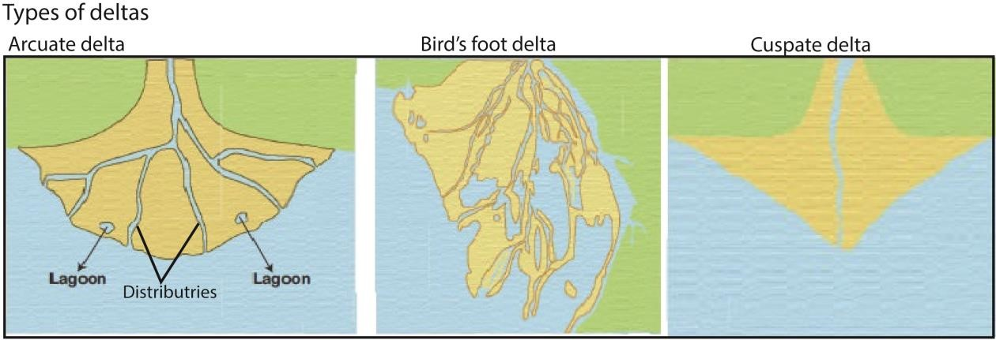
- The arcuate are the fan-shaped deltas. The wider portion of the fan is facing the water. It is formed from relatively coarse sediments e.g. Nile delta in Egypt, Semuliki delta on L. Albert, Rufigi delta, Niger delta etc.
- The bird’s foot delta got its name because it forms like a bird foot’s claw. It is formed by a river carrying very fine materials such as silt into water where wave energy is too weak to remove it. It is characterized by a few long tributaries bordered by levees extending some distance into the sea. Examples are found on river Omo as it enters L.
Turkana from Ethiopia and Victoria Nile as it enters L. Albert.

- The cuspate/estuarine deltas are formed where sediments are deposited onto a straight shoreline with strong waves. The waves push the sediments to spread outwardly creating the tooth-like shape.
Importance of Deltas
- Contain fertile soils for agriculture e.g. Nile delta in Egypt
- Were centres of early civilization e.g. Nile delta in Egypt
- Source of sand and gravel used in construction industry
- Biodiversity hotspot: The river Deltas boast some of the most biodiverse systems on the planet e.g. Sunderbans forests, one of the richest biodiversity hotspots in India.
- Act as a buffer region: The Deltas region provides a buffer for cyclones, as open land often stands to weaken the impact of storms as they travel toward larger, more populated areas. e.g. the Mississippi River Delta, for example, buffers the impact of potentially strong hurricanes in the Gulf of Mexico.
Similarities between alluvial fan and delta
- Both are funnel shaped with apices at the source
- Both are made of sediments with finer materials deposited furthest while the course and heavy materials deposited near the apices.
- Both are formed at appoint where gradient drops and velocity of the river is reduced.
Differences between alluvial fan and delta
- Alluvial fans develop on land away from the sea while deltas form at the mouth of a river where it enters into the sea.
- Alluvial fans have less distinct distributaries while deltas have marked distributaries
- Alluvial fans are formed in the youthful/mature stages of a river while deltas are formed in old/senile stage of a river.
- Alluvial fans are not flanked or associated with swamps, spits, bars, lagoons while deltas are associated or flanked with swamps, lagoons, bars, etc.
- Deposits in alluvial fans are mainly coarse material while deposits in deltas are mainly fine sediments
- Formation of deltas is determined by a number of factors such as presence of sheltered bay, absence of obstruction, absence of tidal currents and differences in salinity between the depositing rivers and the sea. However such factors are not applicable to alluvial fans.

Summary of conditions that lead river deposition
- A drop in river’s gradient leads to reduction in the rivers speed, competence or energy to carry its load.
- An increase in the width of a river valley causes a reduction in speed leading to deposition
- Deposition occurs when a river enters into a stationary water body such as sea, lake and/or ocean because the speed of water reduces due to increased friction.
- Deposition takes place when fresh water enters salty water because clay particles and silt coagulate, become heavy and thus settle.
- Excessive evaporations leads to deposition because reduction in volume reduces the competence of the river to carry the load e.g. in river Omo in northern Kenya
- Increase in the concentration of load due to surface runoff, land slide and domestic wastes in urban areas.
- Nature of river bed; rough river bed characterized by potholes and rapids tends to traps the load leading to deposition

River rejuvenation
River rejuvenation is the renewal of the erosive activity of the river within its old valley.
The causes of river rejuvenation
- Heavy rainfall (climate change) in the catchment areas causes increase in volume of water in the river. This increases the erosive activity resulting into rejuvenation.
- River capture/piracy: As the river cuts back, it breaks into the adjacent valley and captures a nearby stream. This increases the volume of water in the pirate river channel leading to rejuvenation
- Regional uplift along the river course e.g. through faulting causes a gradual steepening of the river's gradient. This increases its velocity (speed) and its erosive activity leading to rejuvenation.
- Isostatic and Eustatic re-adjustments. Negative changes in the sea level (fall in sea level) create a knick point close to the coast resulting into increase in the river gradient, increased speed and its erosive activity.
- Glaciation in the ice caps and ice sheets. This reduces the amount of water reaching oceans such as the Indian Ocean. This results into a fall in the sea level and lowering of the baselevel of rivers. A steep gradient is produced and therefore, the velocity of the river and erosive load leads to an increase in the energy and erosive activity

Effects/landforms due to river rejuvenation.
- V-knick point is a sharp break of slope in the long profile of a river valley. It is a point in the river bed where the old river profile changes into a new river profile. Or a nick point is part of a river or channel where there is a sharp change in channel slope, such as a waterfall or lake.
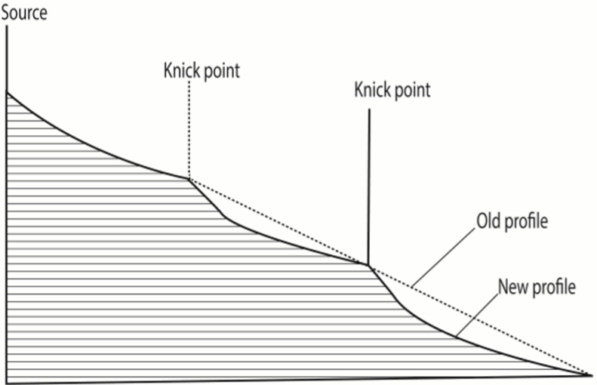
- Valley within a valley /rejuvenated gorge. This refers to a new valley which has been reshaped from the old existing valley. Along rivers where rejuvenation was fairly rapid and the fall in base level quite large, the effect may produce steep sided gouge within the former valley called valley which in a valley e.g. R.Nyando
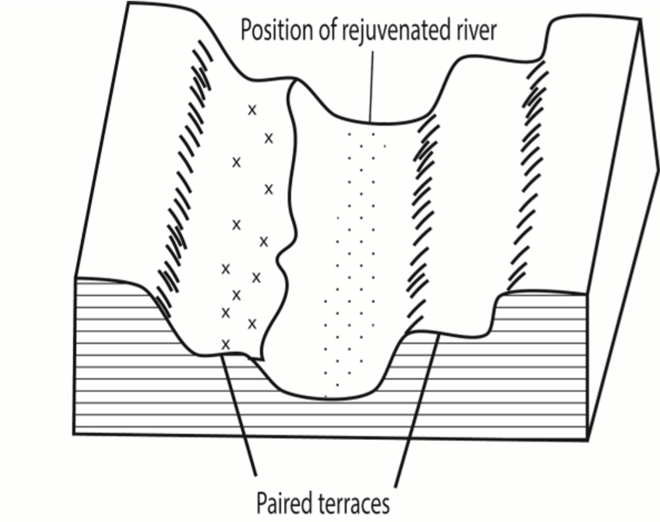
- Stream terraces /paired terraces. These are bench /step like strips of land found above a stream and its flood plain. They are benches cut in a rock or steps formed in sediments by deposition and subsequent erosion. Originally, the river deposited a thick section of flood plain sediments. Then the river changed from deposition to erosion and cut into its old flood plain, parts of which remain as terraces above the river .These terraces are generally of equal height and are called paired terraces e.g. R. Nyando
- Incised meanders .These are steep deep gorges cut into a meandering channel. They are formed when there is rapid vertical erosion of a channel within a meandering river. Th.is results to a meandering-valley with essentially no flood plains; e.g. R. Mwachin, Kombeni. Incised meanders are divided into two; (i) Ingrown meanders. This is a valley with an asymmetrical cross-profile, where one side is steeper than the other. It normally develops on more resistant rocks when vertical erosion increases, e .g. R Mubuku near the KaseseFort portal road, R. Manafa near Busia, along the Tororo - Mbale road.

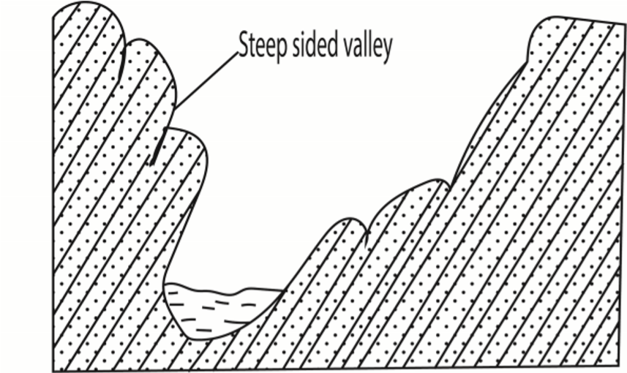

- Entrenched meander. These are valleys with steep sided symmetrical profiles .They develop on weak reeks where there's rapid lowering of the base level

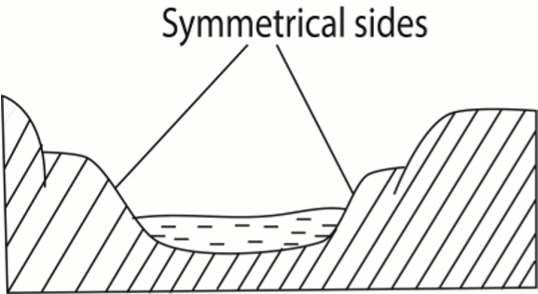

Importance of river erosion and depositional features to human activities
Positive importance
- Waterfalls, rapids and narrow gorge are used for HEP
- Beautiful scenery of waterfalls, rapids, meander are tourist attraction sites
- River valleys have fertile soils for agriculture
- Delta such as that Semuliki contain petroleum deposits
- Delta and river valleys contain sand and clay as building materials
- The mangrove vegetation in the river Rufigi provide poles for construction - Delta are used for fishing
Negative importance
- Rapids and waterfalls hinder transport.
- Deep valleys limit settlement
- Flooding limit agriculture and settlement

River drainage pattern/system
Drainage systemis the physical outlay of a riverand its tribbutaries on the earth’s surface.
- 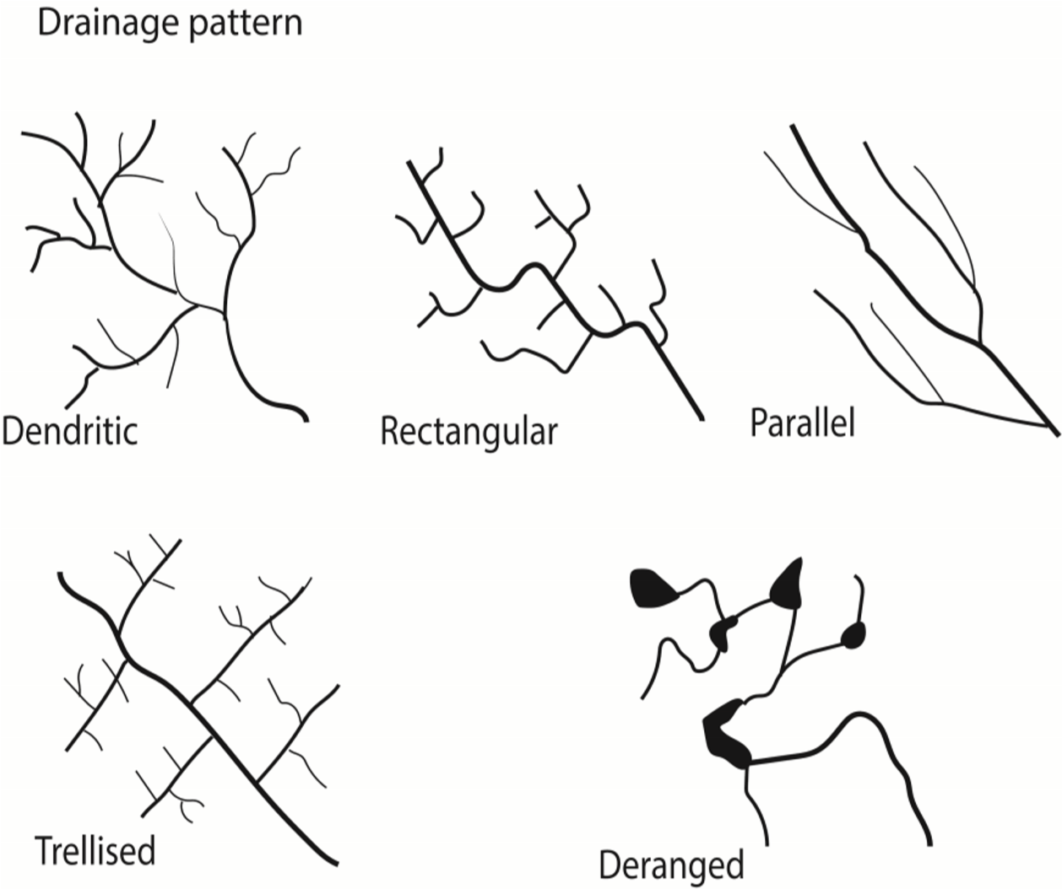

Radial drainage pattern
Radial drainage pattern occurs when several rivers originate from the same domeshaped water shed and flow outwards. It is a drainage pattern associated with mountains. Examples of radial patterns are found on Mt. Elgon comprising rivers Sironko, Manafa, Siti and Koitobos and on Mt. Rwenzori comprising Rivers Mubuku, Nyamugasani, Lume and Ruanoli.

Factors favoring radial drainage pattern
- the presence of a dome or cone shaped highland that provides source of the rivers
- steep slopes that accelerate downward movement and erosion of rocks to create channels along which rivers flow.
- Presence of high highland with uniform rock structure and hardness to enable a river erode on any side of the highland.
- High precipitation in catchment area in form of rainfall, snow or melting glacier to provide constant water supply.
Centripetal drainage pattern
Occurs when several rivers from different directions flow towards a common point e.g. on L. Victoria comprising Katonga, Kagera, Nzoia and Sio.
Factors favoring formation of centripetal drainage
- Presence of depression, basin or valley into which rivers flow.
- Heavy rain fall and reliable rain fall to provide constant supply of water
- Regions with rocks of uniform resistance to erosion
Dendritic drainage pattern
Here tributaries join larger streams at acute angles like braches of a tree. Examples are found on R. Rufigi, Victoria Nile, R. Malagalasi, R. Kagera, R. Congo etc.
Factors favoring formation of dendritic drainage system
- develops in areas where the rock beneath the stream has no particular structure and can be eroded equally easily in all directions.
- Gentle slope
- Heavy rain fall and reliable rain fall to provide constant supply of water in large catchment area.

Trellis/rectilinear drainage patterns
It is pattern which displays a rectilinear shape with tributaries joining the main stream at approximately right angle. Examples occur on R. Mayanja-Kato, Wasswa in Kichwamba, R. Aworanga, Pager, Aswa and Galana.

Factors that favor development of trellis drainage pattern

- Presence of sedimentary rocks that have been folded or tilted, and then eroded to varying degrees depending on their resistance to erosion.
- Heavy rain fall and reliable rain fall to provide constant supply of water in large catchment area. Parallel drainage patterns
It is a drainage pattern where rivers flow by the sides of each other but with limited chances of joining one another. Examples are found in western Uganda where R. Nkusi and R. Hoima are parallel to each other before joining L. Albert. In Kenya they are found in the Aberdare ranges and west of Mau ranges where tributaries of R. Athi such as R. Nairobi, Thirika, Komu and Ruiru flow parallel to each other

Factors favoring formation of parallel drainage system
- Presence of pronounced slope to the surface of uniform rock resistance or in regions of parallel, elongate landforms like outcropping resistant rock bands.
- Rivers flowing in the same direction
- Pronounced divide made of hard rocks between the rivers to limit chances of the rivers joining each other.
- Heavy rain fall and reliable rain fall to provide constant supply of water.

Deranged drainage pattern (has no clear pattern) forms in areas with extensive limestone deposits, where surface streams can disappear into the groundwater via caves and subterranean drainage routes or in areas where there has been much geological disruption or areas with low relief, low slopes, and large sediment loads.

Rectangular drainage Pattern forms where the bedrock is faulted and jointed.

River capture
River capture/stream piracy occurs when a stronger river flowing in a deep channel arrests the waters of an adjacent weak river.
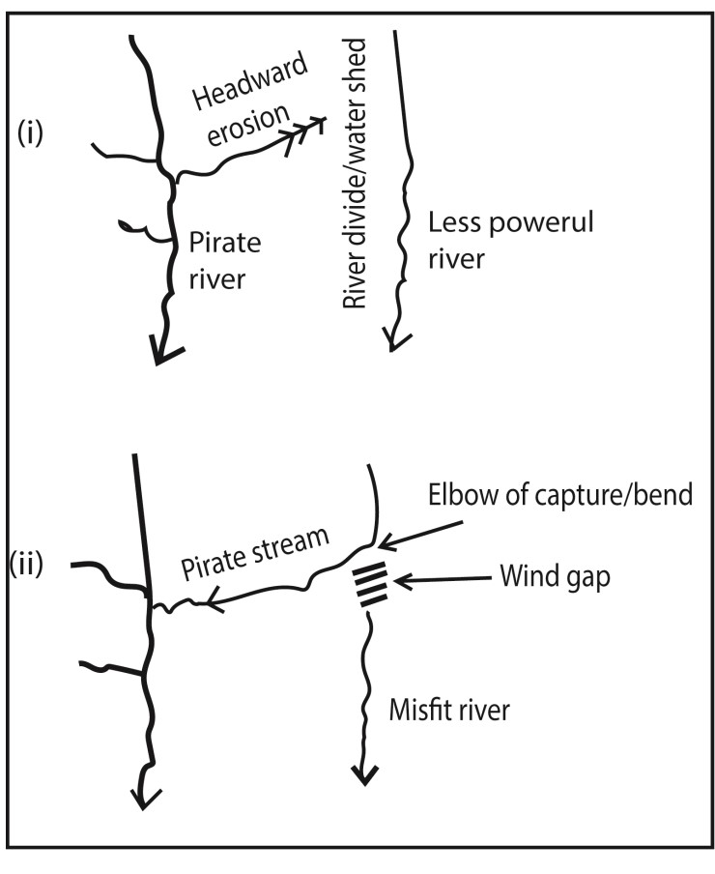
Factors leading to river capture
- River capture occurs where there are 2 adjacent rivers/ share a watershed moving in the same direction; e.g. R. Aswa and R. Agogo
- One river has more erosive power than the others e.g. a powerful R. Nile capture the weak rivers i.e. R. Okole, Tochi and Arocha.
- Differences in rock hardness. A river flowing over soft rocks deeply cuts it’s valley by headward erosion into the valley of one flowing over hard rocks capturing it in the due course. For example R. Wasa flowing on soft rocks eroded and captured R. Nyaboranga in Fort Portal in west Uganda
- River capture can result from river rejuvenation since a rejuvenated river gain strength to capture others
- River capture may also occur as a result of earth movements such as uplift or down warping along the course of one river. A river flowing over a down warped channel may extend its valley by head ward erosion and capture waters of an adjacent weaker river flowing over an uplifted channel e.g. R. Birira in south-west Uganda captured R. Rwizi.
- Difference in gradients along which rivers flow; a river flowing along a steeper gradient is likely to capture a river flowing along less steep gradient. Examples are found in Ghana where R. Nsaki a tributary of R. Dunsu in the Akwapim hills (steeper gradient) captured the Basiasi (gentle gradient)
- Influence of rock joining. A pirate stream/river is flowing over well jointed rock may undertake head ward erosion, deepens it valley and eventually captures a weaker river flowing on massive rocks.
- A pirate stream flowing in a short and direct course can easily capture a weaker river flowing in a long and circuitous course
Process of river capturing
- The more powerful river erodes vertically faster than weaker one thus flows at lower level than the other.
- The more powerful river erodes it's valley towards the other river's valley through headward erosion
- Eventually, the powerful river joins valley of weaker river
- The powerful river diverts the head waters of the weaker river into its channel • The diversion of the headwaters is called river capture.
Terminologies of river capture
- A pirate stream; this is the river through head ward erosion that captures water of another nearby river.
- Beheaded stream /misfit stream; this is the victim stream which has lost its waters due to capture.
- A wind gap; This is the dry valley of the beheaded stream below the point of capture
- Elbow of capture is the bend formed at a point where the headwaters of the captured stream flow into the capturing stream
- Gorge /incised valley; Undercutting of the pirate river near the point of capture due to increased water volume which results into renewed erosion producing a steep and deep valley.
- Knick point; a sharp break in the slope created near the point of capture due to rejuvenation.
- Over Fit River, this is the river that appears too big for its present valley due to increased volume of water from the captured river.
Examples of river capture in east Africa include
- Lower Tiva captured upper Tiva River in eastern Kenya, formally a tributary of river Galana.
- River Aswa captured Agago, Moroto and Pager rivers in northern Uganda; reversed river- Rwizi, Katonga captured weaker adjacent rivers when Western Uganda uplifted.
- River Ruaha captured Pawaga drainage system in Tanzania.
- River Nile captured waters of river tochi, Okole and Arocha etc

Importance of rivers
Positive
- Water transport e.g. R. Tana
- Fishing e.g. R. Nile
- Recreation e.g. R. Nile
- Production of HEP e.g. R. Nile
- Source of building materials such as sand and clay
- Tourist attraction
- Source of minerals such as diamond, gold from alluvial deposits
- Fertile soils in the basins and delta for agriculture
Negative
- Water falls hinder navigation
- May cause flood that destroy crops and animals

Revision exercise 2
- (a) Differentiate between cross profile and long profile of a river.
  - Account for the nonexistence of a graded profile along River Nile
(Define the key words such as river, river cross profile, long profile, and graded profile. Differentiate between the two. Describe the factors that interfered with development of a graded profile along R. Nile. Use examples and diagrams to illustrate your points.)
- Explain the causes and effects of river rejuvenation in East Africa Candidate are expected to define river rejuvenation
(Identify and explain, with illustrations the effects of river rejuvenation)
- (a) Examine the formation of land forms resulting from river erosion and deposition along a long profile of a river.
  - Examine the effects of river erosional and depositional features on human activities. (Describe a long profile of a river and identify its stages. Outline the characteristics of each stage. Describe the processes through which river erosion and deposition operates. Explain the formation of the features. Examples and diagrams may be used to illustrate the point)
- (a) Describe the conditions for formation of a waterfall.
  - Examine the importance of a waterfall on economic development in East Africa. (Define a waterfall; describe the conditions for formation of a waterfall; give positive and negative importance of waterfall)
- Examine the similarities and differences between an alluvial fan and delta
(Define alluvial fan and delta; then give similarities and differences between the two)
- Account for the process of river deposition and describe the formation of its resultant landforms
(Define a river; explain the reasons why rivers are able to carry d
- Account for the occurrence of river rejuvenation and describe the formation of the associated features

Importance of Drainage in Development

(i) Agriculture and Food Security
- Rivers and wetlands provide irrigation for crops.
- Floodplains around rivers like the Nile have fertile soils that support intensive farming.
- Fishing in lakes (Victoria, Kyoga, Albert, Edward, George) sustains millions of livelihoods.

(ii) Hydroelectric Power Generation
- The Victoria Nile supports major dams such as Owen Falls (Nalubaale), Kiira, and Karuma.
- Hydropower is Uganda’s main source of electricity, fueling industrial growth and urban development.

(iii) Transportation and Trade
- Lakes and rivers serve as natural transport routes, especially Lake Victoria which connects Uganda to Kenya and Tanzania.
- Inland water transport reduces costs and supports regional integration.

(iv) Urban Planning and Infrastructure
- Proper drainage prevents flooding in cities like Kampala.
- Roads, bridges, and railways depend on well-managed drainage to remain stable.

(v) Health and Sanitation
- Wetlands filter pollutants and improve water quality.
- Good drainage reduces stagnant water, limiting mosquito breeding and diseases like malaria.

(vi) Environmental Conservation
- Wetlands (e.g., Nabajuzi, Rubigi) act as biodiversity hotspots.
- Drainage systems regulate water flow, prevent desertification, and maintain ecological balance.

(vii) Tourism
• Biodiversity within water bodies and attractive sceneries promote tourism and these provide income to local communities and government.

Negative Impacts of Uganda’s Drainage System on Development
- Flooding and Waterlogging o Rivers and wetlands often overflow during heavy rains, damaging crops, homes, and infrastructure.
  - Urban areas like Kampala face frequent flooding due to poor drainage planning.
- Spread of Waterborne Diseases o Stagnant water in swamps and poorly drained areas encourages mosquito breeding (malaria) and diseases like cholera and bilharzia.
- Loss of Agricultural Land o Floodplains and wetlands, while fertile, can become unusable when water levels rise excessively.
  - Farmers lose harvests due to unpredictable river flooding.
- Infrastructure Damage o Roads, bridges, and railways are weakened by poor drainage, leading to costly repairs.
  - Hydropower dams face siltation, reducing efficiency and lifespan.
- Environmental Degradation o Over-drainage of wetlands for farming or settlement destroys ecosystems.
  - Sedimentation from rivers reduces water quality and affects biodiversity in lakes.
- Conflict Over Resources o Drainage systems like Lake Victoria and the Nile are shared with neighboring countries.
  - Competing demands for water (irrigation, hydropower, fishing) can cause regional tensions.

Case studies to show how drainage features shape development and the challenges they bring.

Case Study 1: The Nile River Basin (Africa) Influence on Development
- Agriculture: The Nile provides irrigation for millions of hectares of farmland in Uganda, Sudan, and Egypt. Ancient civilizations thrived along its fertile floodplains.
- Energy: Hydroelectric dams (e.g., Owen Falls in Uganda, Aswan High Dam in Egypt) generate power for industry and households.
- Transport & Trade: The river is a vital transport corridor, linking regions and supporting commerce.
- Urban Growth: Cities like Cairo and Jinja developed along the Nile due to water access and trade opportunities.
Challenges
- Water Conflicts: Competing demands among Nile Basin countries (Egypt, Ethiopia, Uganda, Sudan) create political tensions.
- Environmental Degradation: Dams alter ecosystems, reduce fish stocks, and cause siltation.
- Flooding & Climate Change: Variability in rainfall threatens agriculture and hydropower reliability.

Case Study 2: The Mississippi River Basin (North America)
Influence on Development
- Agriculture: The Mississippi’s floodplains are among the most fertile in the world, supporting large-scale farming of maize, soybeans, and cotton.
- Transport & Trade: The river is a major shipping route, moving goods from the interior to the Gulf of Mexico.
- Urban Development: Cities like New Orleans, St. Louis, and Memphis grew along the river due to trade and water access.
- Industry: The basin supports industries like petrochemicals, shipping, and fishing.
Challenges
- Flooding: Seasonal floods devastate communities and require extensive levee systems.
- Pollution: Agricultural runoff causes nutrient loading, leading to the “dead zone” in the Gulf of Mexico.
- Infrastructure Strain: Maintaining levees, dams, and navigation channels is costly and complex.
- Climate Change: Increased storm intensity threatens settlements and industries along the river.

Comparative Insights
Aspect | Nile River Basin (Africa) | Mississippi River Basin (USA)
Agriculture | Irrigation for subsistence & cash crops | Large-scale mechanized farming
Energy | Hydropower dams (Owen Falls,  Aswan) | Limited hydropower, focus on transport
Transport | Regional trade corridor | Global shipping hub
Urban growth | Cairo, Jinja, Khartoum | New Orleans, St. Louis, Memphis
Challenges | Water conflicts, siltation, climate variability | Flooding, pollution, infrastructure costs

Conclusion
Both drainage features are development engines:
- The Nile sustains agriculture, energy, and settlement in Africa but faces political and environmental challenges.
- The Mississippi drives agriculture and trade in the USA but struggles with flooding and pollution.
- Together, they show how rivers can be both lifelines and liabilities, depending on how societies manage them.

An example of project designed for promoting the sustainable utilisation of a drainage feature in a local area. Overview
A project promoting the sustainable utilization of a local drainage feature in Uganda should be rooted in a community-based, multi-stakeholder approach that integrates technical solutions with social and environmental considerations. The design should focus on reducing flood risks, enhancing water quality, and providing alternative livelihood options that minimize environmental pressure on the drainage feature

Example

Project Title
Sustainable Utilisation of Lake Victoria Wetlands for Community Development in Kampala Project Goal
To promote the sustainable use of Lake Victoria’s wetlands by balancing economic development, environmental conservation, and community livelihoods.

Objectives
- Conserve biodiversity by protecting wetland habitats from degradation.
- Enhance livelihoods through eco-friendly fishing, farming, and tourism.
- Improve water quality by reducing pollution and promoting waste management.
- Raise awareness among local communities about sustainable drainage use.
- Strengthen governance by involving local councils and environmental agencies.

Key Activities
- Community sensitisation workshops on wetland conservation and sustainable fishing.
- Eco-friendly aquaculture projects to reduce overfishing pressure.
- Wetland restoration (planting papyrus, controlling invasive species).
- Waste management initiatives (community clean-ups, recycling programs).
- Eco-tourism development (bird-watching trails, cultural tours). (vi) Policy advocacy to enforce wetland protection laws.

Expected Outcomes
- Improved water quality in Lake Victoria.
- Increased income for local communities through eco-tourism and sustainable fishing.
- Reduced flooding risks due to restored wetlands.
- Enhanced biodiversity conservation (fish, birds, plants). (v) Stronger community ownership of natural resources.

Challenges
- Population pressure leading to encroachment on wetlands.
- Pollution from industries and households.
- Weak enforcement of environmental laws.
- Climate change impacts (unpredictable rainfall, flooding).

Sustainability Strategies
- Continuous community involvement in decision-making.
- Partnerships with NGOs, schools, and government agencies.
- Income-generating activities tied to conservation (eco-tourism, aquaculture).
- Monitoring and evaluation to track progress.

TOPIC 3/3: Energy Production
Competency: The learner devises innovative ways of developing and using energy through analysing the production, consumption and sustainability of the various sources of energy to balance energy use and environmental stewardship.
Major Energy Resources
The world’s major energy resources include fossil fuels (coal, oil, natural gas), nuclear energy, and renewable sources (hydropower, solar, wind, geothermal, biomass). Fossil fuels still dominate globally, but renewables are rapidly growing in importance.
- Coal o One of the earliest energy sources used by humans. o Still widely used for electricity generation, especially in Asia.
  - High carbon emissions make it less sustainable.
- Oil o Primary source for transportation fuels (petrol, diesel, jet fuel).
  - Also used in petrochemical industries.
  - Vulnerable to price fluctuations and geopolitical tensions.
- Natural Gas o Cleaner than coal and oil, used for heating, electricity, and industry.
  - Increasingly important as a “transition fuel” toward renewables.
- Nuclear Energy o Provides large-scale electricity with low carbon emissions.
  - Challenges include radioactive waste disposal and safety concerns.
- Hydropower
  - Uses flowing water to generate electricity. o Major renewable source in countries like Uganda, China, and Brazil.
  - Can disrupt ecosystems if dams are poorly managed.
- Solar Energy o Harnesses sunlight through photovoltaic cells.
  - Rapidly expanding due to falling costs and global climate goals.
- Wind Energy o Converts wind into electricity using turbines.
  - Growing in Europe, North America, and parts of Africa.
- Geothermal Energy o Uses heat from beneath the Earth’s crust.
  - Reliable but limited to regions with volcanic activity (e.g., Kenya, Iceland).
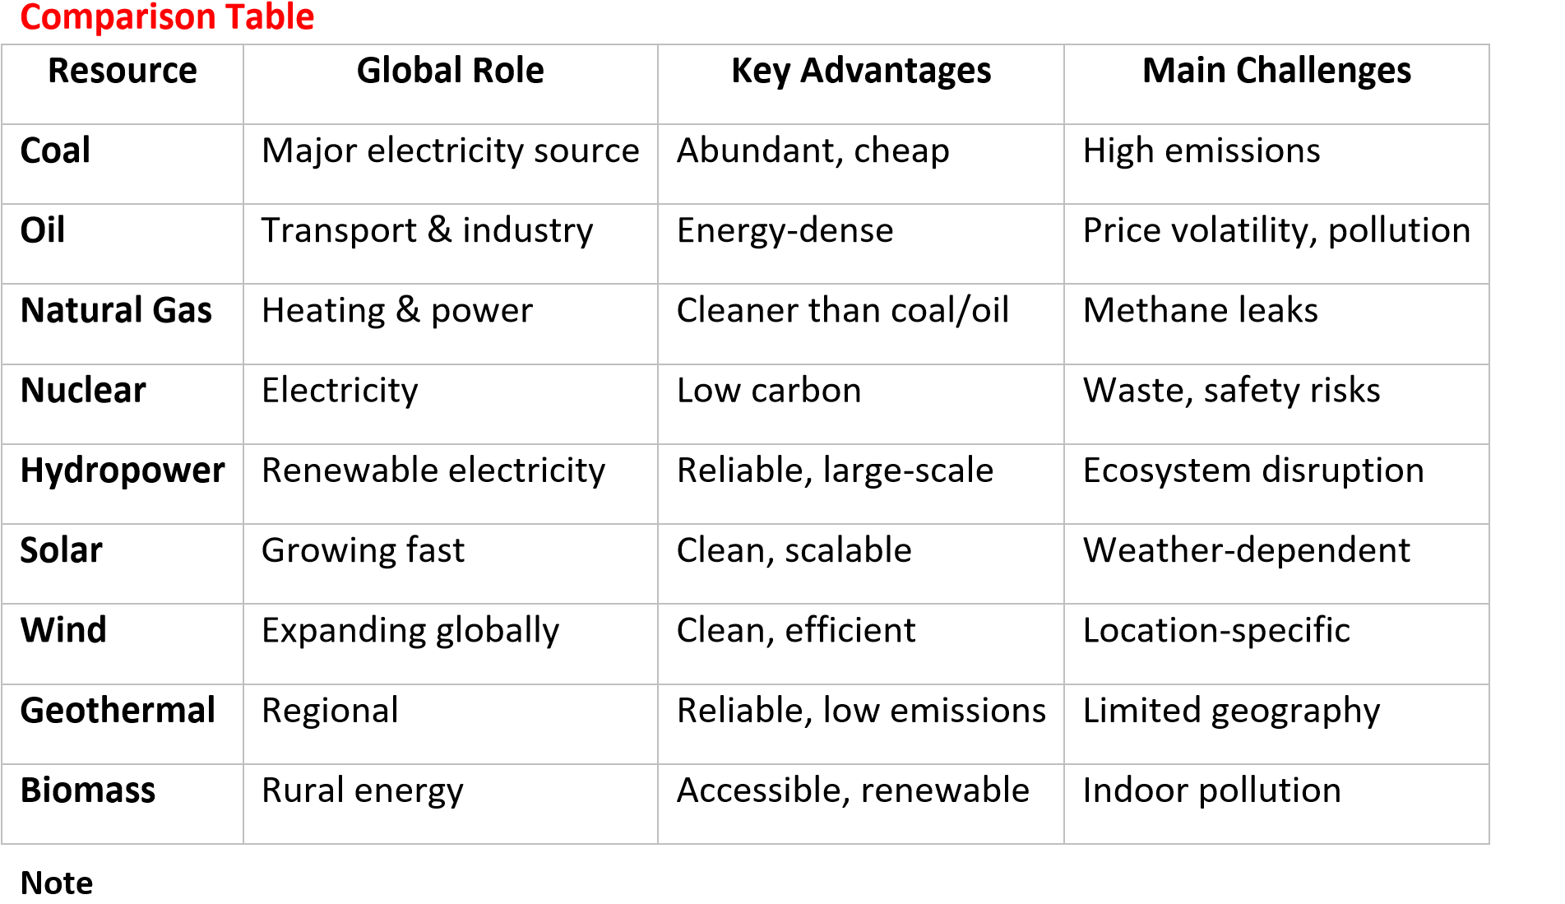
- Biomass o Organic material (wood, crop waste, dung) used for cooking and heating. o Still important in rural areas of Africa and Asia.
- Fossil fuels still supply ~81% of global energy.
- Renewables are crucial for climate change mitigation and energy security.
- Countries like Uganda rely heavily on hydropower, but are exploring solar and biomass to diversify.

Renewable Energy Sources
These are energy sources that naturally replenish and are sustainable over time.
- Solar energy: Harnessed from sunlight using solar panels.
- Wind energy: Generated by wind turbines.
- Hydropower: Produced from flowing water in rivers and dams.
- Geothermal energy: Heat from beneath the Earth’s crust.
- Biomass energy: Organic materials like crop waste, wood, and dung. • Tidal/Wave energy: Energy from ocean tides and waves.
✨ Key feature: They are clean, sustainable, and reduce greenhouse gas emissions.
Non-Renewable Energy Sources
These are energy sources that cannot be replenished quickly; once used, they are depleted.
- Coal: Fossil fuel formed from ancient plant matter.
- Oil (Petroleum): Used for transport fuels and industry.
- Natural gas: Cleaner than coal and oil but still finite.
- Nuclear energy: Uses uranium; though low-carbon, uranium is limited and waste disposal is challenging.
Distribution of energy resources in Uganda
- Hydropower (Renewable) o Concentrated along the Victoria Nile (Nalubaale/Owen Falls, Kiira, Bujagali, Karuma dams).
  - Smaller hydropower stations on rivers like Mpanga, Nyagak, and Ishasha.
  - Provides ~80% of Uganda’s electricity.
- Biomass (Renewable) o Widely used in rural areas (firewood, charcoal, crop residues).
  - Accounts for ~90% of household energy consumption.
  - Distributed across the country, especially in agricultural regions.
- Solar Energy (Renewable) o High potential due to equatorial location. o Solar mini-grids and rooftop systems expanding in rural areas (Karamoja, Northern Uganda).
- Oil & Gas (Non-renewable) o Discovered in the Albertine Graben (Lake Albert region).
  - Reserves estimated at 6.5 billion barrels, with Hoima as the hub for refinery and pipeline projects.
- Geothermal (Renewable, potential) o Sites in Katwe, Buranga, and Kibiro (Western Rift Valley). o Still under exploration, not yet commercialized.
Distribution of Energy Resources in East Africa
- Kenya o Geothermal: Rift Valley (Olkaria, Menengai) – world leader in geothermal power. o Wind: Lake Turkana Wind Project. o Hydropower: Tana River dams.
  - Solar: Northern Kenya (Garissa solar plant).
- Tanzania o Natural Gas: Offshore reserves near Songo Songo and Mnazi Bay. o Coal: Deposits in Ngaka and Kiwira. o Hydropower: Rufiji River (Stiegler’s Gorge project).
  - Renewables: Expanding solar and wind potential.
- Rwanda & Burundi o Hydropower: Shared projects on rivers like Rusumo Falls. o Methane gas: Lake Kivu (Rwanda) – unique energy resource. o Solar: Small-scale rural electrification projects.
Factors influencing the distribution of energy resources
The distribution of energy resources across the world (and within regions like Uganda and East Africa) is shaped by a mix of natural, economic, technological, and political factors. Here’s a clear breakdown:

(i) Natural/Physical Factors
- Geological formations: Fossil fuels (coal, oil, natural gas) occur in sedimentary basins.
Example: Uganda’s oil reserves in the Albertine Graben.
- Climate and sunlight: Solar energy potential is highest in equatorial and desert regions.
Example: East Africa has high solar potential due to year-round sunshine.
- Topography and water flow: Hydropower depends on rivers, waterfalls, and elevation differences. Example: Uganda’s Victoria Nile supports major dams.
- Volcanic activity: Geothermal energy is concentrated in tectonic rift zones. Example: Kenya’s Rift Valley geothermal fields.

(ii) Economic Factors
- Capital investment: Developing energy resources requires huge funding (dams, oil rigs, solar farms).
- Market demand: Regions with high industrial activity prioritize energy development.
- Infrastructure: Transport networks (pipelines, transmission lines) determine where resources can be exploited.

(iii) Technological Factors
- Level of technology: Advanced drilling, solar panel efficiency, and wind turbine design influence resource use.
- Research and innovation: Countries with strong R&D harness renewables more effectively.
- Energy storage: Battery technology affects solar and wind distribution.

(iv) Political & Social Factors
- Government policies: Subsidies, incentives, and regulations shape energy distribution.
- Regional cooperation/conflict: Shared resources (like the Nile) require agreements between countries.
- Environmental concerns: Climate change policies push nations toward renewables.
- Population distribution: Areas with dense populations need more energy infrastructure.
Summary Table

Factor Type

Influence on Distribution

Example

Geolog
ical

Determines fossil fuel & geothermal
locations

Oil in Albertine Graben
Uganda
(
)

Climate

Solar & wind potential

Solar farms in Northern Kenya

Topography

Hydropower sites

Victoria Nile dams

Economic

Investment & demand

Pipelines in Tanzania

Technolog
ical

Efficiency & exploitation

Kenya’s geothermal plants

Political/Social

Policies & cooperation

Nile Basin water agreements

Energy
production and consumption
in Developed Countries

- Production o High reliance on advanced technologies (nuclear, renewables, fossil fuels). o Large-scale infrastructure for oil refining, hydropower, and wind/solar farms.
  - Example: USA produces energy from oil, natural gas, coal, nuclear, and renewables.
- Consumption
  - Very high per capita energy use due to industrialization, transport, and modern lifestyles. o Heavy dependence on electricity and petroleum for cars, industries, and households.
  - Example: USA consumes ~10 times more energy per person than many African countries.
- Implication o Developed countries face challenges of overconsumption, pollution, and climate change, making wise use critical for sustainability.

Energy production and consumption in Developing Countries
- Production o Limited infrastructure; often rely on hydropower, biomass, and small-scale solar.
  - Fossil fuel reserves (oil, gas, coal) may exist but are underdeveloped due to capital constraints.
  - Example: Uganda produces most of its electricity from hydropower (Victoria Nile dams).
- Consumption
  - Lower per capita energy use, but heavy reliance on biomass (firewood, charcoal) for cooking and heating.
  - Electricity access is limited, especially in rural areas.
  - Example: In Uganda, ~90% of households depend on biomass, while only ~30% have reliable electricity.
- Implication o Developing countries face challenges of energy poverty, deforestation, and health risks from biomass use. Wise resource use means expanding clean energy without degrading ecosystems.

Comparative Table
Aspect | Developed Countries | Developing Countries
Production | Diverse: fossil fuels, nuclear, renewables | Mainly hydropower, biomass, smallscale solar
Consumption | High per capita, industrial & transport heavy | Low per capita, household biomass dominant
Challenges | Overconsumption, pollution, climate change | Energy poverty, deforestation, limited access
Need for Wise  Use | Reduce emissions, shift to renewables | Expand clean energy, conserve ecosystems

Why Wise Use of Energy Resources Matters
- Global sustainability: Developed countries must cut emissions, while developing countries must avoid unsustainable exploitation.
- Equity: Wise use ensures fair access to energy for all populations.
- Future security: Conserving non-renewables and investing in renewables prevents crises.
- Health & environment: Reduces pollution, deforestation, and climate risks.

countries in 2024

0
1000
2000
3000
4000
5000
6000
USA
Germany
China
Coal
Thermal gas
Nuclear
Hydro
Wind + solar
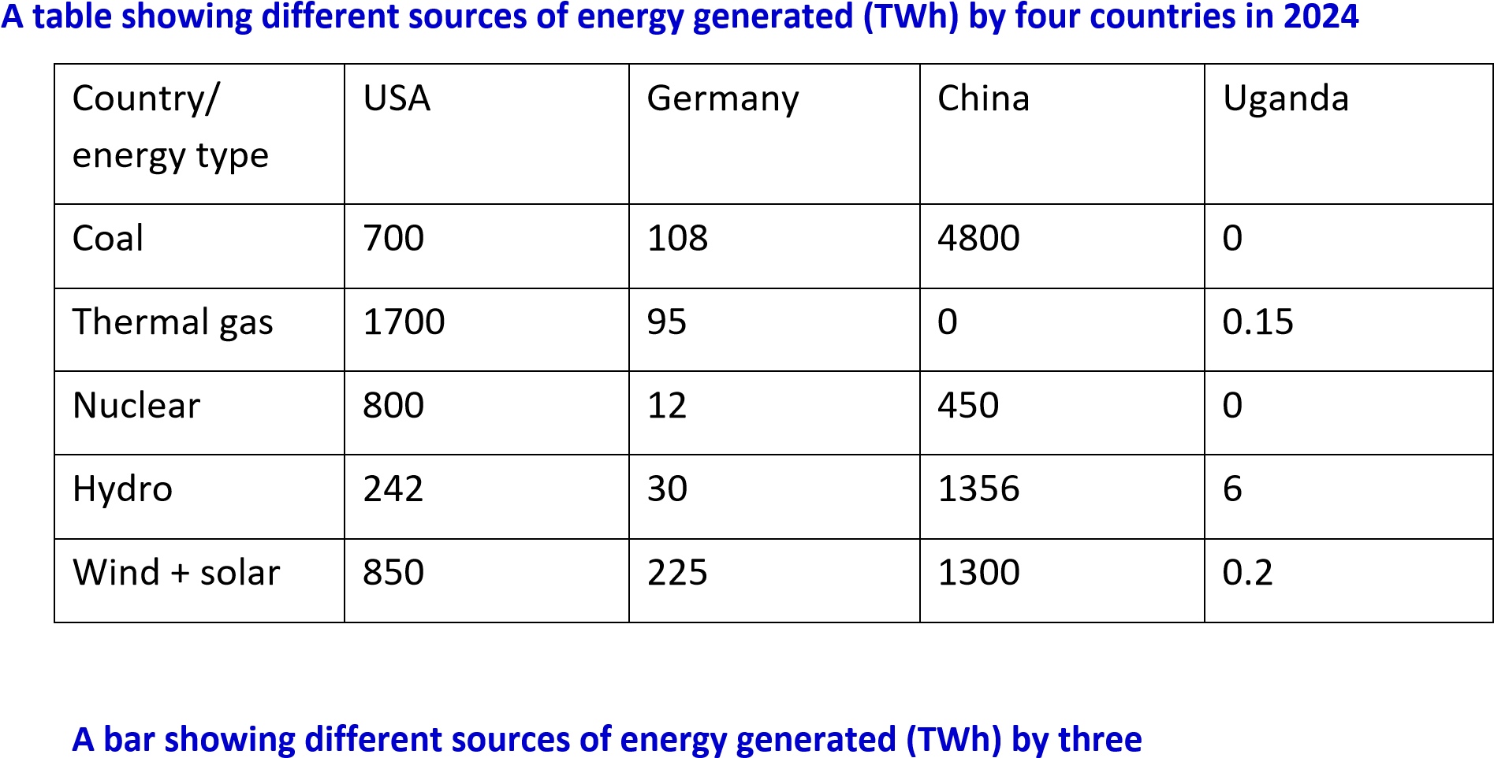
Uganda is not included on the bar chart because it has negligible energy output

The factors affecting the development of energy resources in Uganda
The development of energy resources in Uganda is shaped by natural factors (geology, rivers, climate), economic constraints (capital, infrastructure), technological capacity, political and policy frameworks, and social/environmental considerations.
- Geological and Natural Endowment o Oil reserves in the Albertine Graben provide potential for petroleum development. o Abundant rivers (Victoria Nile, Mpanga, Nyagak) support hydropower. o High solar radiation across the country enables solar energy expansion.
  - Geothermal potential exists in Rift Valley sites (Katwe, Buranga, Kibiro).
- Economic and Financial Constraints o Large-scale projects (hydropower dams, oil refinery, pipelines) require heavy investment.
  - Limited domestic capital means reliance on foreign investors and loans.
  - Energy poverty persists, with many households still dependent on biomass.
- Technological Capacity o Limited local expertise in oil refining, geothermal drilling, and advanced renewables. o Dependence on imported technology raises costs and slows adoption.
  - Weak grid infrastructure limits electricity distribution, especially in rural areas.
- Political and Policy Environment o Government policies (Uganda Energy Transition Plan 2023) emphasize renewables and efficiency.
  - Regional cooperation is needed for shared resources like the Nile.
  - Policy uncertainty and corruption risks can discourage investors.
- Social and Environmental Considerations o Biomass use (firewood, charcoal) causes deforestation and health risks. o Hydropower dams can displace communities and affect ecosystems. o Public acceptance of renewables depends on awareness and affordability. o Climate change impacts (variable rainfall, droughts) affect hydropower reliability.

The factors affecting the development of energy resources in the world
The development of energy resources worldwide is influenced by a complex mix of natural, economic, technological, political, and environmental factors. Here’s a clear breakdown:

(i) Natural / Physical Factors
- Geological formations: Fossil fuels (coal, oil, natural gas) occur in sedimentary basins; geothermal energy is concentrated in tectonic zones.
- Climate and sunlight: Solar energy potential is highest in equatorial and desert regions.
- Topography and water flow: Hydropower depends on rivers, waterfalls, and elevation differences.
- Resource distribution: Uneven global distribution means some regions are resource-rich (Middle East oil, China coal) while others rely on imports.

(ii) Economic Factors
- Capital investment: Energy projects (dams, nuclear plants, oil rigs, solar farms) require huge funding.
- Market demand: Industrialized nations consume more energy, driving development.
- Infrastructure: Pipelines, transmission lines, and refineries determine where resources can be exploited.
- Global trade: Energy resources are traded internationally, influencing development in resource-rich vs resource-poor countries.

(iii) Technological Factors
- Level of technology: Advanced drilling, renewable energy systems, and nuclear reactors enable resource exploitation.
- Innovation: Improvements in solar panels, wind turbines, and battery storage expand renewable use.
- Efficiency: Energy-efficient technologies reduce demand and shape resource development.

(iv) Political & Policy Factors
- Government policies: Subsidies, incentives, and regulations encourage or discourage certain energy sources.
- International agreements: Climate accords (e.g., Paris Agreement) push countries toward renewables.
- Geopolitical tensions: Oil and gas resources often cause conflicts or alliances (e.g., Middle East, Russia-Europe gas).
- Energy security: Nations prioritize domestic production to reduce reliance on imports.

(v) Environmental & Social Factors
- Climate change concerns: Pressure to reduce carbon emissions drives renewable energy development.
- Public acceptance: Nuclear energy faces opposition due to safety concerns; wind farms may face local resistance.
- Population growth: Rising demand for electricity and fuel influences energy development.
- Sustainability: Balancing exploitation with conservation is critical for long-term development.

Table of comparison of the factors affecting the development of energy resources in developed and developing countries
Factor Type Developed Countries Developing Countries
Geological / Often depleted fossil fuel reserves, Rich in untapped resources (oil, gas, Natural but strong investment in hydro, solar), but underutilized due Endowment renewables (solar, wind, nuclear). to limited capital.
Economic / High investment capacity, strong Limited funding, reliance on foreign Financial Capacity infrastructure, diversified energy aid/investors, weak infrastructure,
mix. energy poverty common.
Technological Advanced technology for Limited technology, dependence on
Capacity exploration, refining, renewables, imports, slower adoption of modern and energy storage. energy systems.
Political / Policy Strong regulatory frameworks, Weak enforcement of policies,
Environment climate policies (Paris Agreement), political instability, corruption risks, subsidies for renewables. focus on short-term gains.
Social / Public pressure for clean energy, Heavy reliance on biomass
Environmental strong environmental movements, (firewood, charcoal), deforestation, Factors high awareness of climate change. health risks, low awareness of
sustainability.
Infrastructure & Extensive transmission networks, Poor grid coverage, rural
Access reliable electricity access, smart electrification challenges, reliance
grids. on mini-grids and off-grid solutions.
Global Trade & Major players in global energy Vulnerable to global price
Geopolitics markets, influence prices and fluctuations, often resource
policies. exporters with little local value
addition.

Benefits of harnessing energy development
Harnessing energy development brings wide-ranging benefits for economies, societies, and the environment. Here’s a clear breakdown:
- Economic Benefits
  - Industrial growth: Reliable energy powers factories, businesses, and services.
  - Job creation: Energy projects (hydropower dams, solar farms, oil refineries) create employment.
  - Revenue generation: Export of oil, gas, or electricity earns foreign exchange.
  - Infrastructure expansion: Energy development stimulates roads, transmission lines, and urban growth.
- Social Benefits
- Improved living standards: Access to electricity enables lighting, cooking, refrigeration, and communication.
- Education: Schools benefit from electricity for computers, internet, and lighting.
- Healthcare: Hospitals use energy for equipment, refrigeration of medicines, and clean water supply.
- Rural electrification: Extends opportunities to marginalized communities, reducing inequality.
- Environmental Benefits
  - Renewable energy reduces emissions: Solar, wind, and hydropower cut greenhouse gases compared to fossil fuels.
  - Sustainable resource use: Properly managed energy projects protect ecosystems and reduce deforestation.
  - Climate resilience: Diversified energy sources reduce vulnerability to climate shocks.
- Strategic & Political Benefits
  - Energy security: Countries reduce dependence on imports by harnessing local resources.
  - Regional integration: Shared energy projects (like Nile hydropower or East African pipelines) strengthen cooperation.
  - Global competitiveness: Nations with strong energy systems attract investment and trade.

Problems associated with of harnessing energy development
- Environmental Problems
  - Pollution: Burning fossil fuels releases greenhouse gases, contributing to climate change.
  - Deforestation: Heavy reliance on biomass (firewood, charcoal) leads to forest loss, especially in developing countries.
  - Ecosystem disruption: Hydropower dams alter river flow, affect fish migration, and flood habitats.
  - Waste disposal: Nuclear energy produces radioactive waste that is difficult to manage safely.
- Economic Problems
    - High costs: Energy projects (dams, oil refineries, solar farms) require huge capital investments.
    - Price volatility: Oil and gas prices fluctuate globally, affecting economies.
    - Unequal access: Rural areas often remain underserved, widening the gap between urban and rural communities.
- Technological Problems
    - Limited expertise: Developing countries may lack skilled manpower for advanced energy technologies.
    - Infrastructure gaps: Weak transmission networks cause power losses and unreliable supply.
    - Storage challenges: Renewable sources like solar and wind need effective storage solutions to balance supply.
- Political & Social Problems
    - Resource conflicts: Shared resources (like the Nile waters) can cause disputes between countries.
    - Corruption & mismanagement: Poor governance can delay projects or misuse funds.
    - Displacement of communities: Large projects (dams, oil fields) often force people to relocate.
    - Public resistance: Nuclear plants, wind farms, or pipelines may face opposition due to safety or land concerns.
Uganda’s Key Policies and Strategies for Sustainable Energy
- Energy Policy for Uganda 2023 (EP2023) o Vision: Universal access to sustainable, affordable, and quality energy services for all Ugandans by 2040. o Focus on renewable energy expansion (hydropower, solar, wind, biomass, geothermal).
  - Promote energy efficiency in households, industry, and transport. o Encourage private sector investment and public-private partnerships.
  - Strengthen governance through agencies like ERA (Electricity Regulatory Authority).
- National Development Plan (NDP III, 2020–2025) o Energy sector prioritized as a driver of industrialization. o Targets expansion of electricity generation capacity and rural electrification.
  - Promotes clean cooking solutions to reduce biomass dependence.
- Vision 2040 o Long-term strategy to transform Uganda into a modern, prosperous country. o Energy sector identified as central to economic transformation.
  - Calls for diversification of energy sources and regional integration.
- Renewable Energy Strategy o Promote solar mini-grids and off-grid solutions for rural communities. o Support biomass alternatives (biogas, improved cookstoves).
  - Explore geothermal potential in Rift Valley sites (Katwe, Buranga, Kibiro).
- Electricity Connections Policy (2018–2027) o Aim: Increase electricity access from ~30% to 60% of households. o Subsidizes grid connections for low-income households.

Comparison table of energy policy of Uganda and that of Canada
Uganda’s energy policy (2023) focuses on universal access, renewable expansion, and rural electrification, while Canada’s energy policy (2023 outlook) emphasizes net-zero by 2050, decarbonization, and energy transition pathways. Uganda is tackling energy poverty and infrastructure gaps, whereas Canada is managing emissions reduction and diversification of a mature energy system.

Comparison Table: Uganda vs Canada Energy Policy
Aspect | Uganda Energy Policy 2023 | Canada Energy Future 2023
Vision/Goal | Universal access to sustainable, affordable, quality energy services by 2040 | Achieve net-zero greenhouse gas emissions by 2050
Main Focus | Expand renewables (hydro, solar, biomass, geothermal), improve efficiency, rural electrification | Transition from fossil fuels to renewables, electrification, carbon capture, hydrogen
Challenges  Addressed | Energy poverty, reliance on biomass, weak grid infrastructure, financing gaps | High emissions, fossil fuel dependence, balancing economic growth with climate goals
Key Strategies | Subsidized electricity connections, private sector investment, clean cooking solutions, regional cooperation | Scenario modeling for energy futures, policy pathways for decarbonization, investment in clean tech
Primary  Energy Mix | Hydropower (~80%), biomass (~90% of households), growing solar, oil reserves in Albertine Graben | Oil, natural gas, hydro, nuclear, growing wind/solar
Policy  Instruments | Electricity Connections Policy,  Renewable Energy Strategy, Vision 2040 | Canada Energy Regulator scenarios, federal climate policies, carbon pricing
Long-Term  Outlook | Diversify energy sources, reduce biomass reliance, industrialize sustainably | Net-zero economy, clean energy leadership, global competitiveness

Key Insights
- Uganda: Policy is about access and affordability, tackling energy poverty and expanding renewables to rural areas.
- Canada: Policy is about transition and decarbonization, reducing emissions while maintaining energy security.
- Both highlight sustainability, but Uganda’s priority is development and access, while Canada’s is climate leadership and emissions reduction.

Comparison table of energy policy of Uganda and that of Zimbabwe
Uganda’s energy policy (2023) emphasizes universal access, renewable expansion, and rural electrification, while Zimbabwe’s energy policy (2019 Renewable Energy Policy & Vision 2030 Compact) focuses on clean energy transition, reducing biomass dependence, and achieving universal access by 2030. Uganda is tackling energy poverty with hydropower and solar, while Zimbabwe is prioritizing diversification and climate resilience.

Comparison Table: Uganda vs Zimbabwe Energy Policy
Aspect | Uganda Energy Policy 2023 | Zimbabwe Renewable Energy Policy 2019 & Energy Compact
Vision/Goal | Universal access to sustainable, affordable, quality energy services by 2040 | Clean energy for all Zimbabweans by  2030, aligned with Vision 2030
Main Focus | Expand renewables (hydro, solar, biomass, geothermal), improve efficiency, rural electrification | Promote renewable energy (solar, hydro, wind, biomass), reduce reliance on traditional biomass
Challenges  Addressed | Energy poverty, reliance on biomass, weak grid infrastructure, financing gaps | 38% of population lacks electricity,  61% rely on biomass for cooking
Key Strategies | Subsidized electricity connections, private sector investment, clean cooking solutions, regional cooperation | Renewable energy targets, incentives for private sector, climate resilience,  SDG 7 alignment
Primary  Energy Mix | Hydropower (~80%), biomass (~90% of  households), growing solar, oil reserves in Albertine Graben | Hydropower, solar, biomass, coal; growing focus on solar mini-grids and independent power producers
Policy  Instruments | Electricity Connections Policy,  Renewable Energy Strategy, Vision 2040 | National Renewable Energy Policy  (2019), National Energy Compact  (Vision 2030)
Long-Term  Outlook | Diversify energy sources, reduce biomass reliance, industrialize sustainably | Universal access by 2030, leapfrog to renewables, climate-resilient energy system

Debate whether developing countries should prioritise renewable or non-renewable energy sources to ensure long-term energy security.
Argument for Prioritising Renewable Energy
- Sustainability: Renewables (solar, wind, hydro, geothermal) are inexhaustible and reduce dependence on finite fossil fuels.
- Climate resilience: Developing countries are often most vulnerable to climate change; renewables reduce emissions and environmental damage.
- Energy access: Off-grid solar and mini-grids can quickly electrify rural areas without waiting for costly national grid expansion.
- Economic independence: Reduces reliance on imported oil and gas, shielding economies from global price shocks.
- Job creation: Renewable projects foster local employment in installation, maintenance, and innovation.
Argument for Prioritising Non-Renewable Energy
- Reliability: Fossil fuels (coal, oil, gas) provide consistent baseload power, unlike intermittent solar and wind.
- Existing infrastructure: Many developing countries already have systems built around fossil fuels, making them cheaper to expand in the short term.
- Revenue generation: Oil and gas exports can bring in foreign exchange to fund development.
- Industrialization needs: Heavy industries often require large, stable energy supplies that renewables may struggle to provide without advanced storage.
- Transition fuel: Natural gas, in particular, is seen as a bridge between coal/oil and renewables.

Comparative Table
Aspect | Renewables | Non-Renewables
Availability | Abundant, naturally replenished | Finite, geographically uneven
Cost Trend | Falling costs (solar, wind) | Rising costs, price volatility
Environmental Impact | Low emissions, eco-friendly | High emissions, pollution
Infrastructure Needs | Requires new grids, storage | Uses existing systems
Energy Security | Reduces import dependence | Vulnerable to global markets
Suitability for Growth | Good for rural electrification | Strong for industrial baseload

Conclusion
- Short-term: Non-renewables may still play a role in industrialization and revenue generation.
- Long-term: Renewables are the only sustainable path to energy security, especially for countries like Uganda that have abundant solar and hydropower potential.
- Balanced approach: Developing countries should adopt a hybrid strategy—using nonrenewables as transition fuels while aggressively scaling up renewables to secure their future.

